**CHAPTER-1**

**INTRODUCTION**

**1 INTRODUCTION**

In the evolving digital era, small businesses, freelancers, and individuals often face challenges in managing their digital presence due to the complexity and cost of traditional website solutions. To address these limitations, this project proposes the Content Craft Hub, a modern, scalable, and intuitive Content Management System (CMS) built using the MERN stack (MongoDB, Express.js, React, Node.js). The platform aims to provide users with an all-in-one solution to efficiently manage blogs, websites, and portfolios without requiring extensive technical knowledge. Hosted on platform like GitHub Pages, the solution is designed to be both open-source and easy to deploy.

In today’s fast-paced and digitally driven world, having an online presence is no longer optional—it is essential. Whether it’s a freelancer showcasing their portfolio, a small business promoting its services, or a content creator running a blog, the need for a reliable, user-friendly, and cost-effective website solution has never been greater. However, traditional Content Management Systems (CMS) often present a steep learning curve, incur recurring costs, and require considerable technical expertise to set up and maintain. This creates a significant barrier for individuals and small teams with limited resources or technical knowledge.

To address these challenges, this project introduces the Content Craft Hub a modern, lightweight, and scalable CMS built using the powerful MERN stack: MongoDB, Express.js, React, and Node.js. Designed with ease of use and flexibility in mind, Content Craft Hub aims to democratize website and content management by providing an intuitive platform where users can create, manage, and publish their digital content effortlessly.

* 1. **Objective**

The primary goal of this project is to design and implement a feature-rich CMS that empowers users to create and maintain digital content seamlessly. The system prioritizes usability, scalability, and performance while integrating essential modern web features such as multilingual support, e-commerce compatibility, SEO optimization, and cloud integration.

This CMS is crafted using the **MERN stack (MongoDB, Express.js, React, Node.js),** which ensures a modular and maintainable architecture that supports future enhancements and integration. It aims to bridge the gap between technical complexity and user empowerment by eliminating the traditional barriers that prevent non-developers from managing web content effectively.

1. **User-Centric Design:** Deliver a highly intuitive interface that enables users to manage websites, blogs, and portfolios without any prior coding knowledge.
2. **Scalability:** Develop a robust backend capable of supporting projects ranging from single-page portfolios to full-scale e-commerce websites.
3. **Performance Optimization:** Ensure quick load times and responsiveness across devices through front-end optimization and backend efficiency.
4. **Open-Source Development:** Make the platform available as a free and open-source solution to promote community contributions, transparency, and continuous improvement.
5. **Advanced Web Features:** Incorporate essential modern functionalities such as:
   * **Multilingual support** for global accessibility.
   * **E-commerce compatibility** for product and transaction management.
   * **SEO optimization** to improve search engine visibility.
   * **Cloud integration** for secure storage and deployment flexibility (e.g., AWS, Firebase).
6. Small businesses seeking cost-effective, customizable website solutions.
7. Freelancers aiming to showcase portfolios with minimal setup effort.
8. Users with limited coding knowledge needing intuitive tools.
9. Entrepreneurs looking for scalable CMS with SEO and analytics support.
10. Educational institutions and hobbyists requiring multilingual and media-rich platforms.
11. **Small Businesses**: Local shops, startups, and service providers often lack the budget or expertise for custom-built websites. Content Craft Hub provides a cost-effective, customizable solution for maintaining professional websites, blogs, or online catalogs.
12. **Freelancers and Creatives**: Individuals such as designers, writers, and photographers require visually appealing and easily manageable platforms to showcase portfolios, publish content, and attract potential clients with minimal setup time.
13. **Non-Technical Users**: Many aspiring bloggers, entrepreneurs, or hobbyists do not possess web development skills. The CMS’s drag-and-drop components, template-driven structure, and simplified content editing tools lower the barrier to entry.
14. **Entrepreneurs and Startups**: For digital entrepreneurs aiming to scale their brand presence, the CMS provides advanced features such as SEO tools, analytics dashboards, and plug-and-play e-commerce modules, all within a single cohesive system.
15. **Educational Institutions and Hobbyists**: Schools, clubs, and individual learners often need a simple platform to share updates, projects, or multimedia content in multiple languages. Content Craft Hub supports rich media uploads, multilingual configurations, and educational blog structures to suit this demographic.
    1. **System Features & Technologies**

The **Content Craft Hub** is architected to deliver a powerful yet accessible web content management experience, built using modern technologies and design principles. The system emphasizes **customizability**, **scalability**, and **ease of deployment**, making it ideal for users of varying technical backgrounds. The features and technology stack selected ensure that the CMS is both future-ready and user-friendly, with strong support for responsive design, dynamic content handling, and cloud integration.

The system is designed with the following core objectives:

* Implement a **drag-and-drop builder** and content customization tools.
* Ensure responsive design using **HTML, CSS, Bootstrap, and JavaScript**.
* Integrate backend with **Node.js** and **MongoDB/PostgreSQL** for dynamic content handling.
* Support **cloud-based media management**, **SEO optimization**, and **multilingual content**.
* Enable smooth hosting and deployment via **GitHub Pages** and **GitHub Pages**.

Deliver an open-source, community-friendly solution hosted on GitHub.

1. **Drag-and-Drop Builder**
   * Users can build and customize web pages visually through an intuitive drag-and-drop interface.
   * Predefined blocks for text, media, forms, and widgets allow for quick design iterations without coding.
   * Real-time preview and auto-save functionality enhance user experience.
2. **Responsive and Accessible Design**
   * Built using **HTML5**, **CSS3**, **Bootstrap**, and **JavaScript**, ensuring optimal display across desktops, tablets, and mobile devices.
   * Accessibility features include keyboard navigation, semantic elements, and ARIA support.
3. **Dynamic Content Management**
   * The backend is powered by **Node.js** and integrates with either **MongoDB** or **PostgreSQL**, providing flexible, scalable data storage.
   * RESTful API architecture supports dynamic content operations such as post creation, media uploads, and content categorization.
4. **Advanced Web Support**
   * **Cloud-Based Media Management**: Allows users to upload and manage media assets (images, videos, files) with cloud services like AWS S3 or Firebase.
   * **Multilingual Content**: Built-in support for internationalization (i18n), enabling users to create and display content in multiple languages.
   * **SEO Optimization**: Includes metadata editing, canonical URLs, sitemap generation, and integration with tools like Google Analytics and Search Console.
5. **Seamless Deployment & Hosting**
   * Optimized for deployment on platforms such as **GitHub Pages**, **Vercel**, and **Render**, simplifying the hosting process for developers and non-developers alike.
   * CI/CD pipelines can be configured for auto-deployment from a GitHub repository.
6. **Open Source and Community-Oriented**
   * The entire platform is hosted on **GitHub**, promoting transparency and inviting contributions from the developer community.
   * Well-documented codebase and issue tracking to facilitate collaboration and continuous improvement.

**1.3 Development Phases**

The **Content Craft Hub** project will be carried out through a series of well-structured development phases to ensure clarity, consistency, and high-quality delivery. Each phase is aligned with standard software development practices, enabling iterative improvement and facilitating both short-term goals and long-term scalability.

The project will be executed in the following structured phases:

1. **Problem Identification & Literature Review**  
   Analyze current CMS limitations and research existing platforms to identify pain points and gaps.

**Activities:**

* Analyze widely-used CMS platforms (e.g., WordPress, Joomla, Wix, Ghost) to evaluate complexity, cost, usability, and feature sets.
* Identify common pain points, such as:
  + Difficult setup for non-technical users
  + Limited customization in free tiers
  + Lack of integration with modern deployment methods

1. **Requirement Analysis & System Design**  
   Gather technical and functional requirements; design architecture using the MERN stack.

**Activities:**

* Conduct stakeholder interviews and surveys (freelancers, small business owners, developers) to collect user requirements.
* Define system specifications including:
  + User roles (admin, editor, viewer)
  + Content structure (pages, posts, categories, media)
  + SEO, multilingual support, cloud integration

1. **Development & Implementation**  
   Build frontend and backend modules with integrated functionalities.

**Activities:**

* **Frontend Development:**
  + Build responsive UI with React and Bootstrap
  + Implement drag-and-drop content builder
  + Develop multilingual and SEO-friendly templates
* **Backend Development:**
  + Set up Express.js server and connect MongoDB/PostgreSQL
  + Implement content management APIs, user authentication, and cloud media handling
* Integrate third-party services (e.g., Firebase for media storage, Google Analytics for traffic tracking)

1. **Testing & Deployment**  
   Conduct thorough testing, performance optimization, and deploy the system.

**Activities:**

* Conduct various testing strategies:
  + Unit testing for individual components and functions
  + Integration testing to ensure modules work together
  + UI/UX testing for usability and responsiveness
  + Security and performance audits
* Fix bugs and optimize loading speed, API response time, and user workflows
* Deploy the system using platforms such as:
  + GitHub Pages (for static content)
  + Vercel or Render (for dynamic backend support)

1. **Evaluation & Future Enhancements**  
   Assess system performance, gather feedback, and plan further improvements like plugin support or AI-based content recommendations.

**Activities:**

* Conduct user testing sessions and gather feedback via surveys or interviews
* Analyze performance metrics and usability issues
* Compare achieved outcomes against planned objectives
* Identify and plan future enhancements such as:
  + Plugin/module support system
  + AI-driven features (e.g., content suggestions, image optimization, voice-enabled editing)
  + Mobile app version for on-the-go editing
  + Integration with payment gateways and CRM tool

**CHAPTER 2**

**SYSTEM ANALYSIS**

**2 SYSTEM ANALYSIS**

The System Analysis phase is crucial to understanding the challenges and opportunities that the Content Craft Hub CMS seeks to address. It involves identifying the key needs of users, exploring existing solutions, and analyzing the technical and functional requirements for developing an efficient and scalable platform. This phase helps in laying the foundation for the design, development, and implementation of the CMS. The analysis includes a detailed review of existing CMS platforms, user expectations, and technical limitations, which will guide the system’s architecture and features.

The System Analysis phase plays a critical role in shaping the vision, scope, and core functionalities of the Content Craft Hub. It forms the backbone of the project by providing a clear understanding of both the user needs and the technological landscape, enabling the development of a system that is both practical and forward-thinking.

This phase is not only about identifying what the CMS should do, but also about understanding why it should do it and how to achieve it efficiently. Through careful examination of user pain points, competitor platforms, and current market demands, the analysis ensures that the resulting platform is well-aligned with real-world requirements.

**2.1 Identification of Need**

The need for a comprehensive yet simple-to-use Content Management System is evident in the challenges faced by small businesses and freelancers in managing their digital presence. Traditional CMS platforms often require significant technical knowledge and customization, which can be a barrier for non-technical users. The need for a flexible, cost-effective, and intuitive solution arises from the following points:

* **Complexity of Existing Solutions:** Many CMS platforms are difficult for non-technical users to navigate, requiring technical expertise to customize and maintain.

Many mainstream CMS platforms such as WordPress, Drupal, or Joomla, while powerful, often come with steep learning curves. They require users to:

* Understand themes, plugins, hosting, and backend settings.
* Learn how to modify code or configure server environments.
* Troubleshoot compatibility and performance issues manually.

**Non-technical users-**like freelance designers or local shop owners often find themselves overwhelmed by the technical jargon and convoluted setup processes. As a result, they either abandon the project, hire expensive developers, or settle for subpar DIY website builders that lack flexibility.

* **High Costs**: Traditional CMS platforms can be expensive, especially for small businesses or freelancers who are just starting out.

Building and maintaining a website with traditional CMS solutions often involves significant hidden costs, including:

* Web hosting and domain subscriptions.
* Premium themes and plugins.
* Developer fees for customization or maintenance.
* Ongoing costs for security, performance optimization, and backups.

These expenses can be burdensome for:

* Freelancers starting out.
* Small businesses on tight budgets.
* Nonprofits or educators managing small web projects.
* **Lack of Personalization**: Many existing platforms lack the ability to offer personalized, unique designs without significant development work.

Many website builders and CMS platforms restrict design flexibility, forcing users to conform to predefined templates or rely on costly custom development. Users often struggle to:

* Achieve a unique look that matches their brand identity.
* Modify the layout, color scheme, or components without coding.
* Build interactive or dynamic elements that suit their content goals.

**Content Craft Hub** empowers users through:

* A **modular layout system** with drag-and-drop blocks.
* Fully **customizable design options** (themes, fonts, colors).
* Support for advanced components like galleries, forms, and widgets.
* **Limited Flexibility**: Existing CMS solutions often come with rigid structures that do not allow for easy scalability or customization.

Traditional CMS platforms often enforce rigid content structures and have limited scalability options for growing projects. This becomes problematic when:

* Users want to transition from a blog to a full e-commerce site.
* Additional features (e.g., analytics, user roles, cloud integration) are needed.
* The system must support multilingual content or media-rich pages.

**Content Craft Hub** is developed with a **scalable architecture** using the **MERN stack**, enabling:

* Seamless integration with additional services (e.g., Firebase, Stripe).
* Role-based user management and multi-language content.
* Cloud-hosted media management and advanced SEO features.
* **Technical Barriers**: Users often face challenges in building and maintaining websites due to lack of technical expertise.

One of the largest gaps in the current CMS ecosystem is the barrier posed by technical requirements. Many potential users:

* Lack knowledge of HTML, CSS, or server-side scripting.
* Struggle with FTP uploads, database setup, or SSL certificates.
* Depend on external help to troubleshoot or update their site.

By offering a **code-free experience**, Content Craft Hub allows users to:

* Build and manage their website without needing to write a single line of code.
* Deploy directly from a GitHub repository with automatic version control.

**2.2 Preliminary Investigation**

In this phase, a preliminary investigation into existing CMS platforms and technologies was conducted to understand the **current market landscape** and **user requirements**. The following factors were considered during the investigation:

* **Existing Solutions**: Popular CMS platforms like **WordPress**, **Wix**, and **Squarespace** were analyzed for their features, ease of use, scalability, and cost-effectiveness.A comparative study was conducted on widely-used CMS platforms, particularly **WordPress**, **Wix**, and **Squarespace**, which dominate the market for personal and business websites. Each platform was evaluated on key parameters such as **usability, customization, scalability, performance, and cost**.
* While these platforms offer varying strengths, **none fully meet the needs of users who require both ease-of-use and flexible, cost-effective customization**. There remains a significant gap for a solution that combines the simplicity of Wix with the power and extensibility of WordPress, but without the associated complexity or cost.
* **User Feedback**: User feedback and surveys were collected to understand the challenges faced by small businesses and freelancers when using existing platforms.

Direct insights were gathered from target users, including **freelancers, small business owners, content creators, and educators**, through informal interviews, online forums, and survey responses. The following recurring themes emerged:

* Users struggle with the **steep learning curve** of traditional CMS platforms.
* There is a demand for **affordable or free solutions** that don’t compromise on quality.
* Many users desire **a visual interface** with drag-and-drop functionality.
* Personal branding and content control are important, yet existing tools often feel too “cookie-cutter.”
* Users want **multilingual support**, especially in non-English-speaking regions.
* **Technological Feasibility**: Various web technologies, including the **MERN stack**, were evaluated for their ability to provide an optimal solution in terms of performance, scalability, and ease of use.

A range of web development technologies was evaluated based on **development flexibility, scalability, performance, and learning curve**. The **MERN stack (MongoDB, Express.js, React, Node.js)** emerged as the ideal choice due to its:

* **Modularity and scalability**, making it suitable for both small and large projects.
* **High performance**, with a non-blocking event-driven architecture in Node.js.
* **Modern development approach**, using component-based design with React.
* **Strong community support**, abundant documentation, and integration options.

Alternative stacks like **LAMP**, **MEVN**, or proprietary platforms (e.g., .NET CMSs) were considered but ultimately fell short in terms of front-end reactivity, API-based extensibility, and ease of hosting on free-tier platforms like GitHub or Vercel.

* **Competitive Analysis**: An analysis of competitors' offerings highlighted the gaps in flexibility, customization, and ease of use that the **Content Craft Hub** aims to address.
* There is a market opportunity for a **flexible, open-source CMS** that empowers users with powerful features like **drag-and-drop page design, multilingual support, SEO tools**, and **cost-effective deployment**, all while being easy to use and extend.

The findings from the preliminary investigation informed the choice of technologies and features to be implemented, ensuring that the CMS would be both user-centric and technically robust.

**CHAPTER 3**

**FEASIBILITY STUDY**

**3 FEASIBILITY STUDY**

The Feasibility Study phase assesses the practicality of developing the Content Craft Hub CMS by evaluating its technical and operational aspects. This study helps ensure that the proposed system is both achievable within the project’s constraints and able to meet the needs of users effectively. It also considers resource availability, system capabilities, and the overall impact on users and businesses. By evaluating these aspects, the project team can identify potential risks and develop mitigation strategies for a successful implementation.

The Feasibility Study phase is essential in assessing the practical viability of developing the Content Craft Hub CMS. It ensures that the system can be successfully developed, deployed, and scaled within the given constraints-such as time, budget, and available resources—while effectively meeting the needs of the target users. This phase is crucial for identifying any technical, operational, and resource-related challenges early in the process and for formulating strategies to address them.

The study evaluates the CMS project from multiple dimensions: technical feasibility, operational feasibility, economic feasibility, and legal or regulatory feasibility. Each aspect provides critical insight into the overall practicality of the proposed solution.

**3.1 Technically Feasibility**

The technical feasibility of the **Content Craft Hub** CMS has been thoroughly assessed to ensure that the proposed platform can be developed using available technologies and resources. The system will be built using the **MERN stack** (MongoDB, Express.js, React, Node.js), which offers the following benefits:

* **Scalable Architecture**: The MERN stack allows for seamless scaling, ensuring that the CMS can handle increasing traffic and user demands.

**Technically Feasibility**

The technical feasibility of the **Content Craft Hub** CMS has been thoroughly assessed to ensure that the proposed platform can be developed using available technologies and resources. The system will be built using the **MERN stack** (MongoDB, Express.js, React, Node.js), which offers the following benefits:

* **Scalable Architecture**: The MERN stack allows for seamless scaling, ensuring that the CMS can handle increasing traffic and user demands.
* **Performance Efficiency**: The combination of **Node.js** and **MongoDB** ensures optimal backend performance, capable of handling large amounts of data and concurrent users.
* **Rich User Interface**: React provides a dynamic and responsive user interface, enabling real-time updates and a smooth user experience.
* **Modern Technologies**: The use of **HTML, CSS, Bootstrap**, and **JavaScript** ensures compatibility across different devices and browsers while allowing for a clean, modern design.
* **Cloud Integration**: The platform will utilize cloud-based services for media storage and real-time content management, ensuring reliability and ease of access.

All necessary tools, libraries, and frameworks are readily available, and there is a strong developer community to support the implementation of these technologies. The feasibility of hosting the CMS on platforms such as **GitHub Pages** and **GitHub Pages** has been confirmed, providing cost-effective and scalable deployment options.

* **Performance Efficiency**: The combination of **Node.js** and **MongoDB** ensures optimal backend performance, capable of handling large amounts of data and concurrent users.
* **Node.js**: The non-blocking, asynchronous nature of Node.js allows for high concurrency. The server can handle multiple requests at once without blocking other processes. This is crucial for the CMS, especially when managing multiple content pieces or large media files.
* **MongoDB**: MongoDB’s ability to handle vast amounts of data without sacrificing speed is a key factor. It supports **indexing**, which makes it highly efficient for query performance. Additionally, its **replication** and **sharding** features allow the database to maintain high availability and scalability.
* **Express.js**: As a minimalistic and flexible framework, Express.js ensures that only the necessary code is executed, which leads to faster response times and more efficient data handling.
* **React**: React's **virtual DOM** ensures that the system only re-renders the components that have changed, optimizing the speed of rendering and improving the user experience. This dynamic, single-page application (SPA) design reduces loading times and makes the CMS more interactive.

**How React Enhances the User interface:**

* **Real-time Updates**: React enables **real-time interaction** between the frontend and backend. As users make changes to content, such as editing blog posts or rearranging website sections, they can see those updates immediately without needing to refresh the page.
* **Component-Based Architecture**: React’s reusable components make it easy to build a consistent and maintainable UI. Each component (e.g., buttons, text fields, image galleries) can be developed and modified independently, which improves the development cycle and allows for customizability.
* **Responsive Design**: React integrates seamlessly with **CSS frameworks** such as **Bootstrap** or **Material UI** to ensure that the user interface is **responsive** and works across a variety of screen sizes—from desktops to mobile devices. This is essential for the growing trend of mobile-first web design.

**UI/UX Features in the CMS:**

* **Drag-and-Drop Builder**: Users can easily add, remove, and reorder content sections (e.g., images, text blocks) without requiring any coding skills. This visual interface makes managing content straightforward and intuitive.
* **Customizable Themes**: The CMS will provide **pre-built themes** that users can modify based on their brand and content needs. React's flexibility allows these themes to be easily adapted, ensuring a unique look for each user’s site.
* **Modern Technologies**: The use of **HTML, CSS, Bootstrap**, and **JavaScript** ensures compatibility across different devices and browsers while allowing for a clean, modern design.

**Benefits of Cloud Integration:**

* **Reliability and Performance**: Cloud services (such as **AWS S3**, **Google Cloud Storage**, or **Firebase Storage**) offer **high availability** and **low-latency** access to media files, such as images, videos, and PDFs. This ensures that users can upload and access their content reliably, without burdening the CMS server itself.
* **Scalability**: Cloud storage services are inherently scalable, meaning that as the amount of media data grows (e.g., users upload more images, videos, or documents), the CMS will not experience performance degradation.
* **Cost-Effectiveness**: Using cloud storage for media management reduces the cost of maintaining local infrastructure, as cloud providers operate on a **pay-as-you-go** model, which scales with the amount of storage and bandwidth used.

**Cross-Browser Compatibility:**

* **HTML5** and **CSS3** provide rich multimedia support and a flexible layout model, while ensuring the CMS works smoothly across all modern web browsers (e.g., Chrome, Firefox, Safari).
* **Bootstrap** offers pre-built **responsive grids** and **UI components**, making it easy to implement consistent design across multiple screen sizes without needing extensive custom styling.

All necessary tools, libraries, and frameworks are readily available, and there is a strong developer community to support the implementation of these technologies. The feasibility of hosting the CMS on platforms such as **GitHub Pages** and **GitHub Pages** has been confirmed, providing cost-effective and scalable deployment options.

**3.2 Operational Feasibility**

Operational feasibility focuses on whether the **Content Craft Hub** CMS can be effectively implemented and used within an organizational context. This includes evaluating the ability to deploy and maintain the system with minimal disruption to business operations. The operational aspects of the CMS are designed to be intuitive and user-friendly, ensuring that businesses can quickly adopt the platform without needing extensive technical support. Key factors include:

* **Ease of Use**: The CMS will provide a drag-and-drop interface, customization tools, and real-time content updates, enabling non-technical users to manage their websites without prior experience.

**Key Features Supporting Ease of Use:**

* **Drag-and-Drop Interface**: The CMS will feature a **drag-and-drop builder** that allows users to easily rearrange content blocks, upload media, and configure pages. This eliminates the need for coding, making the platform highly accessible to individuals with no web development experience.
* **Real-Time Content Updates**: Users can see changes in real-time as they make edits to their content. This feature is crucial for users who want to see immediate results without having to manually refresh or preview their changes.
* **Customizable Templates**: The CMS will provide a variety of **pre-designed templates** that users can customize to match their branding. This allows for personalization without requiring any design or coding skills.
* **Simple Navigation**: The platform will be designed with an intuitive **user interface (UI)**, ensuring that even users who are new to website management can quickly learn how to navigate the system and find the tools they need.

**Support Strategies:**

* **Comprehensive Documentation**: The CMS will provide **detailed user manuals** and guides covering every aspect of the system. This documentation will include step-by-step instructions on setting up, customizing, and managing the platform.
* **Video Tutorials**: Short **video tutorials** will be available, allowing users to quickly understand how to use the drag-and-drop builder, integrate external tools, or perform specific actions like optimizing for SEO.
* **Community Support**: The platform will be open-source, with a **community-driven support system** through forums and discussion groups. Users can seek help, ask questions, and share tips with other users, fostering a collaborative learning environment.
* **Customer Service**: For users who need personalized support, an option for **premium customer service** can be offered, including email and live chat support, to assist with more complex issues or troubleshooting.

**Deployment Features:**

* **Cloud-Based Hosting (GitHub Pages)**: The CMS will be hosted on **GitHub Pages**, a cost-effective and reliable solution for deploying static websites. GitHub Pages provides an easy-to-use platform for hosting the frontend of the CMS, offering **automatic deployments** from a connected GitHub repository, eliminating the need for manual intervention.
* **Backend Deployment**: The **backend** of the CMS (powered by Node.js and Express.js) can be deployed on various **cloud platforms** like **Heroku**, **AWS**, or **Google Cloud**. These platforms provide scalable infrastructure that can handle increased demand as the CMS grows.
* **Automatic Updates**: The CMS will be designed with **version control** in mind, using GitHub’s integrated features to push automatic updates. Whenever there are bug fixes, new features, or improvements, users will receive updates without manual effort.
* **Maintenance-Free User Experience**: Since the platform will be cloud-hosted and utilize automated deployment tools, users won’t need to worry about server maintenance, database management, or content backups. These tasks will be handled by the backend services, ensuring that users can focus solely on creating and managing content.

**User Adoption Strategies:**

* **Cost-Effectiveness**: One of the key selling points of the CMS is its **open-source** nature and **low-cost** hosting options. GitHub Pages and other free-tier cloud hosting options ensure that users can access a fully-featured CMS at minimal or no cost. This is particularly appealing for small businesses and freelancers who may not have the budget for expensive CMS platforms.
* **Customizability**: The platform allows for a high degree of **personalization**, from custom themes to the ability to add custom features via plugins. This ensures that users can create a digital presence that aligns with their unique brand and needs, which is a critical factor for adoption.
* **User-Centric Features**: By focusing on **intuitive design** and **ease of use**, the CMS eliminates many of the barriers that non-technical users face when adopting traditional CMS platforms. Users can create websites, blogs, and portfolios without needing specialized technical knowledge, which improves the overall adoption rate.
* **Multilingual Support**: The CMS will include built-in support for **multiple languages**, allowing users to target global markets and broaden their reach. This is particularly important for businesses and educational institutions that want to offer content in more than one language.

**Key Features for Multilingual and Accessibility Needs:**

* **Multilingual Content Support**: The CMS will allow users to create content in multiple languages, offering localized experiences for a global audience. This will be achieved by integrating **i18n** (internationalization) libraries, enabling easy translation of text and content.
* **Language Selector**: Users can easily select their preferred language, and the platform will automatically switch to the selected language for all content, UI elements, and settings.
* **Accessibility Compliance**: The CMS will adhere to the latest **Web Content Accessibility Guidelines (WCAG)**, ensuring that it is fully accessible to individuals with disabilities. Features like screen reader compatibility, keyboard navigation, color contrast optimization, and alt text for images will be incorporated to make the platform usable for all users.

By incorporating **multilingual support** and **accessibility features**, the CMS will ensure a wider reach, including users with different language preferences and those who require special accessibility tools.The operational feasibility of this system has been validated, with consideration for user adoption, ease of deployment, and long-term sustainability in mind.

**CHAPTER 4**

**ANALYSIS**

**4 ANALYSIS**

In the **Content Craft Hub CMS**, a thorough analysis of the system’s structure is vital to ensure its efficient functioning. This section explores the data flow and the relationships within the database using the **Data Flow Diagram (DFD)** and the **Entity Relationship Diagram (ER Diagram)**. The system is built using the **MERN stack**, with **MongoDB** as the database, **Express.js** to manage the backend connections, **React** for the frontend, and **Node.js** for runtime execution. This section also provides a detailed look at how these technologies interact and the flow of data throughout the system.

**Key Technologies Used in the System:**

* **MongoDB**: A NoSQL database, used to store user data, blog content, portfolios, media assets, and other dynamic content.
* **Express.js**: A lightweight framework for Node.js that facilitates backend routing, API requests, and serves as an intermediary between the database and the front-end.
* **React**: A JavaScript library for building dynamic, single-page user interfaces (SPAs) that handle real-time updates and manage state across various components of the CMS.
* **Node.js**: The runtime environment that executes JavaScript code on the server side, enabling backend functionality like handling API requests and interacting with the database.

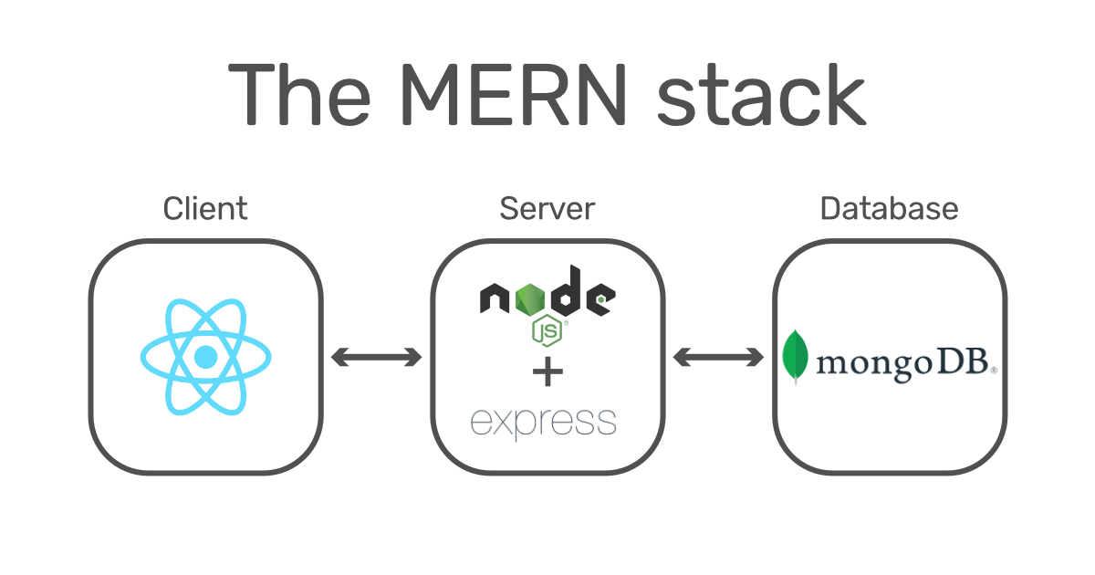

Figure 4.1 MERN Stack Description

**4.1 DFD (Data Flow Diagram)**

The **Data Flow Diagram (DFD)** depicts the flow of data between different components in the **Content Craft Hub CMS**. It shows the interaction between users, the frontend, backend, and the database. The DFD illustrates the following main data processes:

1. **User Authentication**:
   * **Input**: The user provides their **email ID**, **name**, and **password** for signing in or signing up.
   * **Process**: The **Express.js** backend communicates with the **MongoDB** database to validate the user credentials. If the credentials are valid, a session is established.
   * **Output**: The authenticated user gains access to the system, and the session remains active until the user logs out. This allows the user to create posts, view their dashboard, and interact with the CMS.
2. **Post Creation**:
   * **Input**: The user inputs the **post category** (e.g., "announcement", "update") and **content** (the body of the post) via the frontend interface built with **React**.
   * **Process**: The data is sent to the backend via **Node.js**. **Express.js** processes the data and stores it in the **MongoDB** database.
   * **Output**: The post is successfully stored in the database with a **timestamp** marking when it was created. The post is now available for viewing, editing, or sharing based on the user’s permissions.
3. **Post Retrieval**:
   * **Input**: The user requests to view their posts or the posts associated with their account from the dashboard.
   * **Process**: **Express.js** queries the **MongoDB** database for the relevant posts using the user’s session data to filter the posts.
   * **Output**: The posts are retrieved and displayed to the user in an easily navigable format, sorted by categories or date, based on user preference.
4. **Post Editing**:
   * **Input**: The user selects an existing post and makes changes to the content or category.
   * **Process**: The new post data is sent to **Node.js**, which updates the post record in **MongoDB**.
   * **Output**: The updated post is displayed in the user’s dashboard with the newly edited content and metadata.

**Level 0 Data Flow Diagram :**

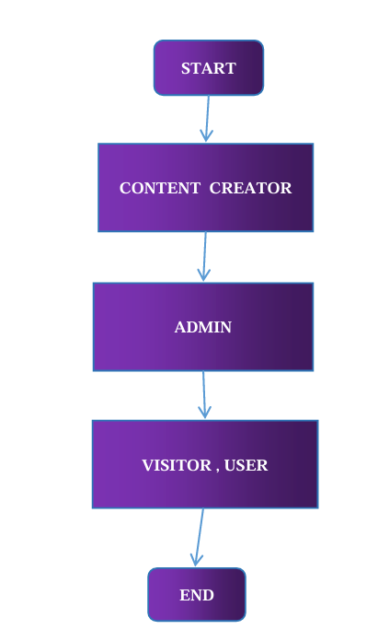

Figure 4.2 DFD Level 0 diagram

**Level 1 Data Flow Diagram :**

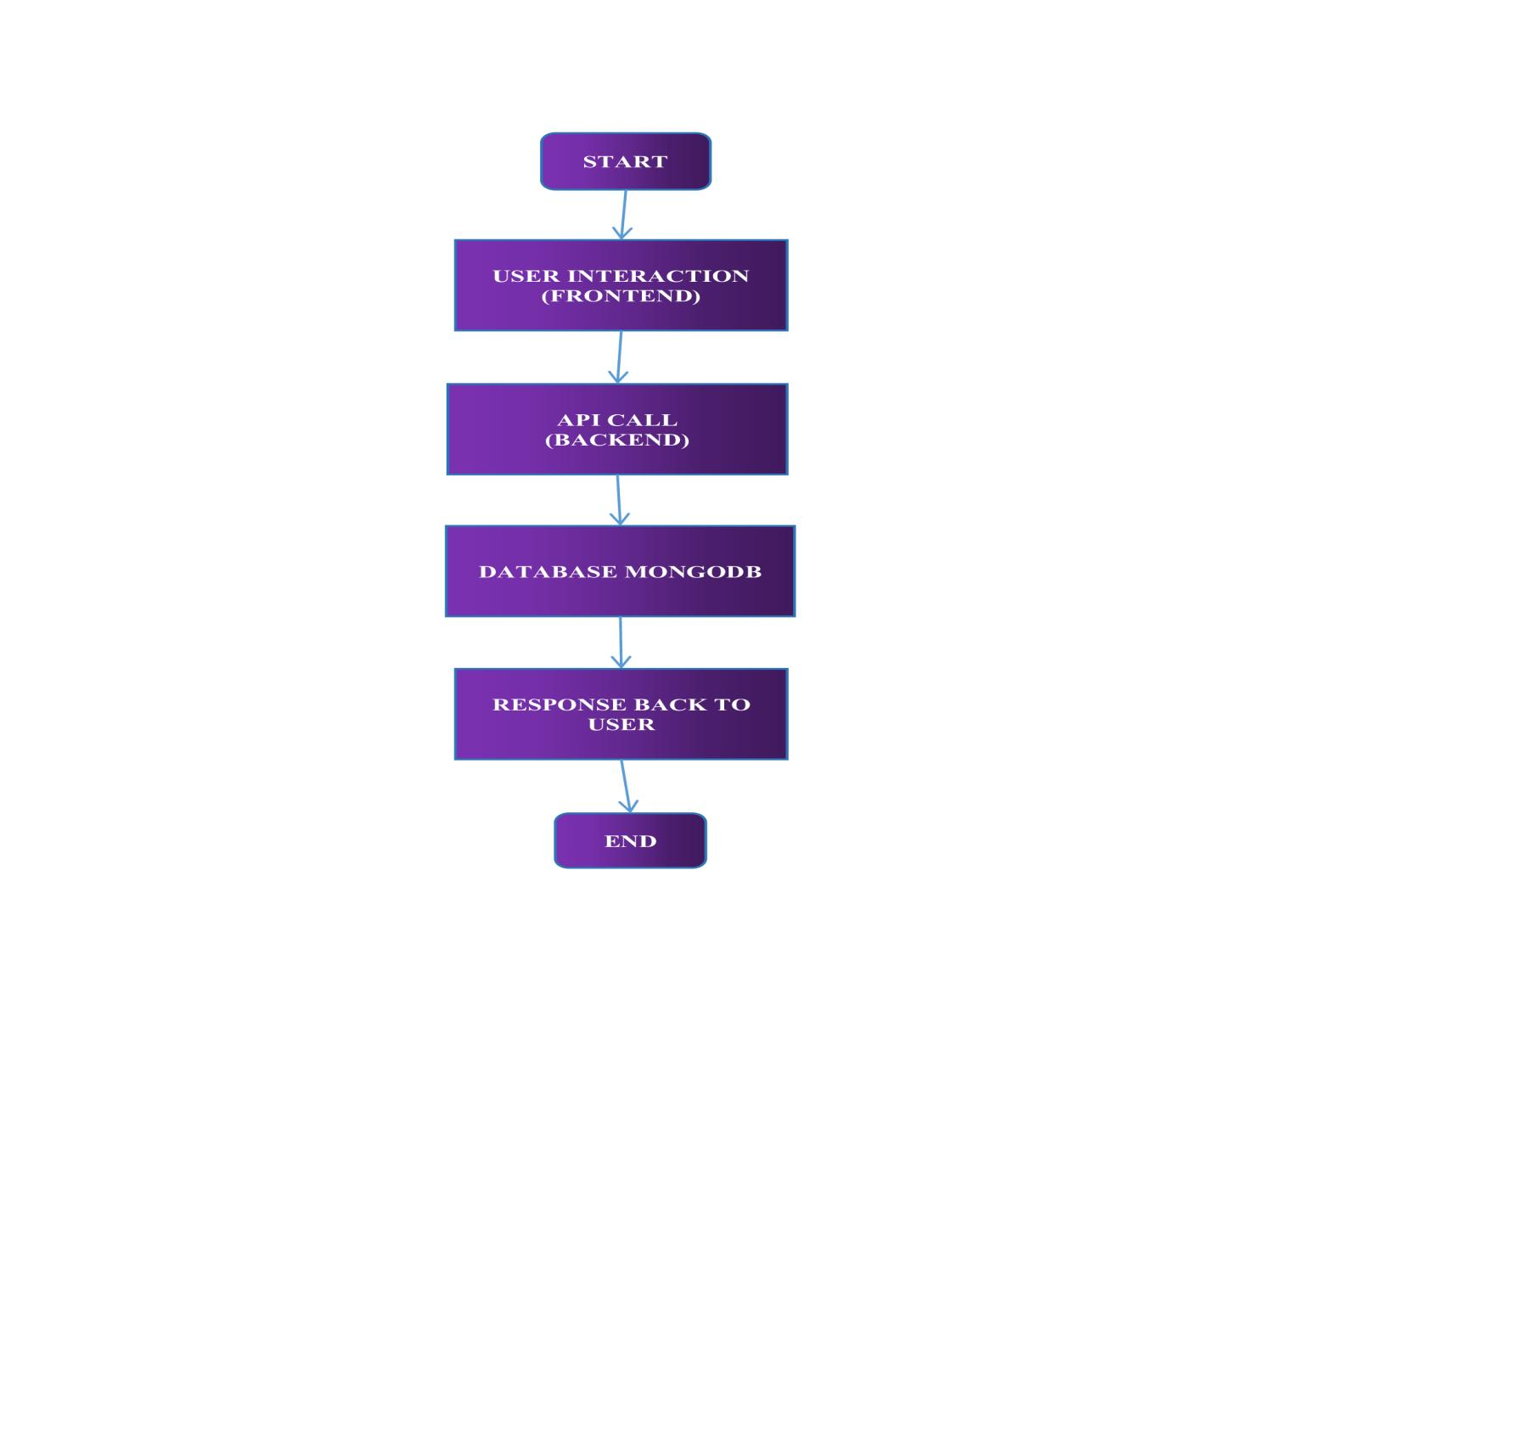

Figure 4.3 DFD Level 1 diagram

**Level 2 Data Flow Diagram :**

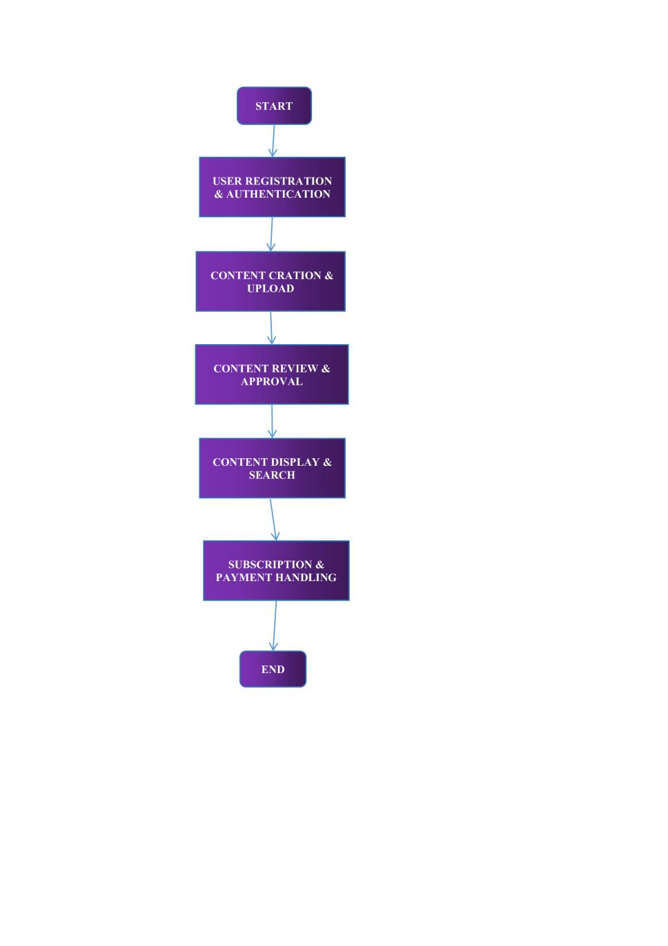

Figure 4.4 DFD Level 1 diagram

**4.2 ER Diagram (Entity Relationship Diagram)**

The **Entity Relationship Diagram (ER Diagram)** illustrates the relationships between different entities in the **MongoDB** database. This diagram helps to define how data is stored and related to other data within the system. The key entities in the **Content Craft Hub CMS** include **User** and **Post**, and the relationships between these entities are defined as follows:

1. **User Entity**:
   * Represents the users of the **Content Craft Hub CMS**, each having unique login credentials.
   * **Attributes**:
     + **email**: A unique email address used for signing in and signing up. It serves as the primary identifier for each user.
     + **name**: The user’s name, used to personalize the CMS interface and posts.
     + **password**: The encrypted password for authenticating the user.
2. **Post Entity**:
   * Represents the posts created by users within the CMS.
   * **Attributes**:
     + **postType**: A label or category for the post (e.g., "announcement", "update"). This helps to categorize the posts for easier management.
     + **content**: The body or actual content of the post, where users can add text, images, or links.
     + **dateCreated**: A timestamp that records the date and time when the post was created. This is automatically set to the current date and time when a new post is created.
   * Each **Post** entity is linked to a **User** who created it.
3. **Relationship Between User and Post**:
   * There is a **one-to-many relationship** between **User** and **Post**, meaning one user can create multiple posts, but each post is tied to one specific user.
   * This relationship allows for efficient management of posts by each user, ensuring that posts are correctly attributed to their creators. The system can easily retrieve all posts associated with a given user by querying the database using the user’s unique **email** or **userID**.

**MongoDB Database Structure:**

The **Content Craft Hub** uses **MongoDB**, a NoSQL database, to store data in a flexible, schema-less format. This allows for easy scaling and quick adjustments as the platform grows. The key collections and their attributes are as follows:

1. **Users Collection**:
   * **email**: The primary key for user identification.
   * **name**: The user’s full name.
   * **password**: The encrypted password for authentication.
2. **Posts Collection**:
   * **postType**: A string indicating the type or category of the post (e.g., "announcement", "update").
   * **content**: The main text or body content of the post.
   * **dateCreated**: The date and time the post was created, automatically generated when the post is saved to the database.
   * **userID**: A reference to the **User** entity who created the post, establishing the one-to-many relationship.

By using **MongoDB**, the platform ensures efficient handling of content and user data, enabling flexible management of dynamic content while maintaining performance.

**Integration with Python ML Models for Content Categorization:**

Once the data is stored in the **MongoDB** database, it is further processed to improve content management using **Python ML models**. The **ML model** is applied to calculate the **similarity score** between posts and to **automatically assign categories** to new posts based on their content. Here's a breakdown of the process:

1. **Data Extraction**:
   * After posts are created and stored in the database, relevant data (post content) is extracted from the **Posts Collection** in **MongoDB**.
2. **Preprocessing**:
   * The content data is cleaned and tokenized using text processing techniques in Python. This may include **removing stop words**, **stemming**, or **lemmatization** to prepare the text data for the machine learning model.
3. **Feature Extraction**:
   * Various features such as **TF-IDF** (Term Frequency-Inverse Document Frequency) or **word embeddings** (e.g., **Word2Vec** or **GloVe**) are extracted from the post content to represent the text data in a vector format that the model can process.
4. **Similarity Calculation**:
   * The model then calculates the **similarity score** between the new post and the existing posts. A high similarity score indicates that the new post shares similar content with other posts already in the database.
5. **Category Assignment**:
   * Based on the similarity score, the model classifies the new post into the most appropriate category, such as **"announcement"**, **"update"**, or others. The category is then saved back into the database along with the post.

This approach ensures that the platform can dynamically categorize content and help users easily navigate through posts of similar topics, improving user experience and content discoverability.

**Entity Relationship Diagram :**

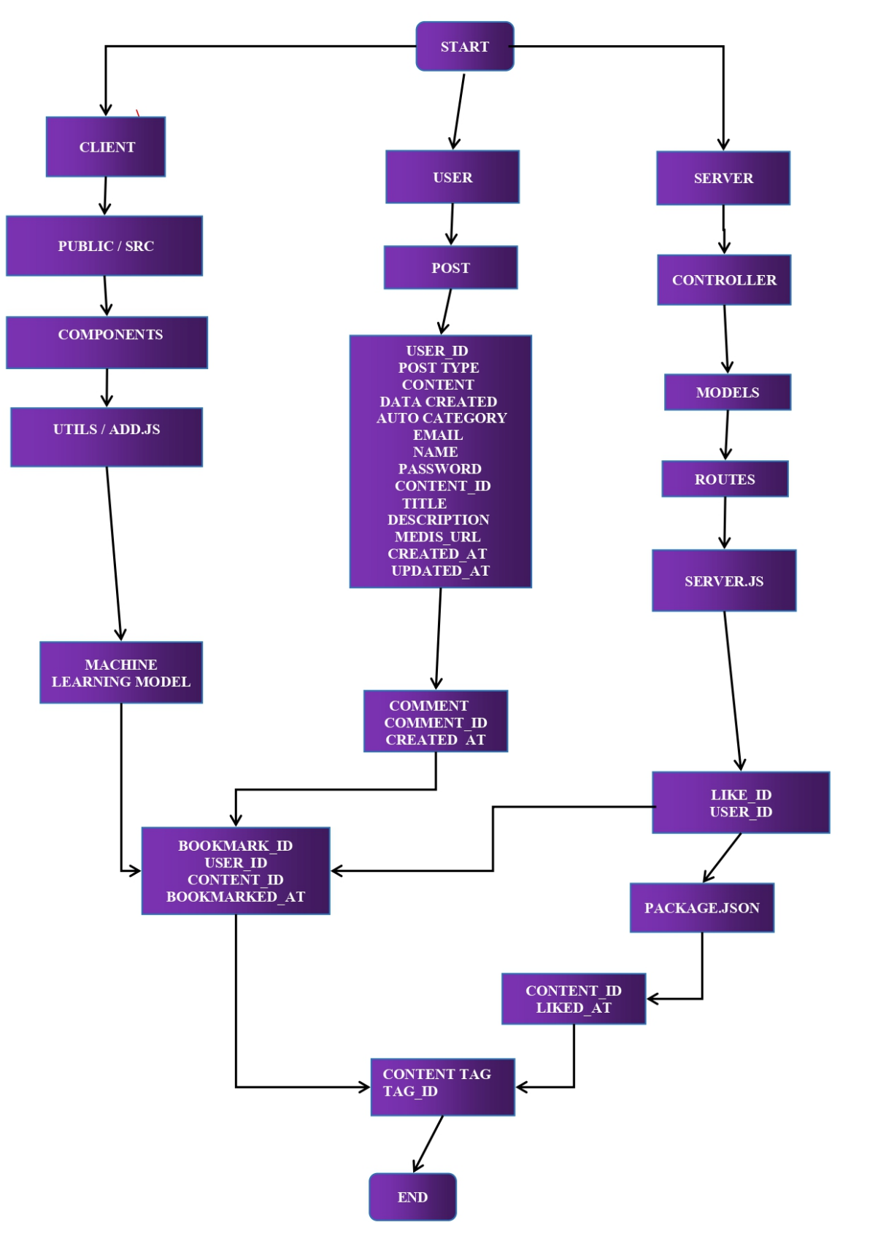

Figure 4.5 ER diagram

**CHAPTER 5**

**METHODOLOGY**

**5 METHODOLOGY**

This section outlines the methodologies and approaches utilized in the development and execution of the Content Craft Hub CMS project. The methodology focuses on how data was collected, processed, and analyzed to ensure the system's optimal performance. The analysis will cover project design, data collection methods, dataset description, and the overall data analysis process.

It represents the systematic approach adopted during the design, development, and evaluation of the Content Craft Hub CMS. The methodology ensures that all phases of the project—from data collection to system deployment—are carried out in a structured, replicable, and efficient manner. This includes defining the project design, methods for data collection, dataset processing techniques, and analysis workflows used to refine features like intelligent categorization and user experience optimization.

**5.1 Project Design**

The Content Craft Hub CMS project is built using the MERN stack, which includes MongoDB, Express.js, React, and Node.js. This CMS system is designed to manage and organize posts, providing users with a platform to create, edit, and view content. The goal of the project was to create a highly scalable and efficient content management system that can easily grow with the platform's increasing content needs.

1. **Architectural Overview**

The system follows a **client-server architecture** with a **modular design**. Key layers include:

* **Frontend (React)**:
  + Offers a responsive and interactive user interface.
  + Implements a drag-and-drop editor, real-time previewing, and multilingual support.
  + React Router handles client-side routing, allowing for seamless navigation.
  + Axios is used for API calls to the backend.
* **Backend (Node.js + Express.js)**:
  + Manages user sessions, post CRUD operations, and API routing.
  + Connects to both the MongoDB database and the external ML classification service.
  + Handles authentication using JWT (JSON Web Tokens) and bcrypt for secure password encryption.
* **Database (MongoDB)**:
  + Stores data in a flexible, JSON-like format that supports rapid iteration and dynamic content.
  + Collections include **Users**, **Posts**, **Media**, **Categories**, and **Comments**.
* **Machine Learning Service (Python Microservice)**:
  + Accepts text content via API and returns categorized tags or classifications.
  + Utilizes NLP techniques and pre-trained models for semantic similarity and classification.

1. **Core System Workflows**

* **User Authentication**:
  + New users register by providing an email, name, and password.
  + Upon login, users are authenticated using JWT and assigned roles (e.g., Admin, Contributor).
* **Post Management**:
  + Authenticated users can create, edit, or delete posts via a WYSIWYG (What You See Is What You Get) editor.
  + Each post is associated with metadata: postType, tags, dateCreated, and userID.
* **Media Upload**:
  + Users can upload images or videos using a cloud-based storage system (e.g., Cloudinary or AWS S3).
  + Media is linked to posts and users for organization and reusability.
* **Automatic Content Categorization (ML Integration)**:
  + When a post is created, its text content is sent to a Python-based ML API.
  + The model analyzes the text, computes similarity scores, and returns the most relevant category (e.g., "News", "Tutorial").
  + The returned category is auto-populated into the post metadata and stored in MongoDB.
* **Post Retrieval and Display**:
  + Users can filter posts by category, date, author, or keyword using an intelligent search system.
  + React dynamically renders posts, with pagination and lazy loading to enhance performance.

1. **Key Design Objectives**

* **Scalability**:
  + Horizontal scaling is supported through cloud-based hosting and stateless backend architecture.
  + MongoDB’s document-based design handles large, unstructured data efficiently.
* **Security**:
  + Secure authentication, encrypted passwords, and role-based access control (RBAC) protect user data and admin functionalities.
* **Extensibility**:
  + The modular structure allows easy integration of additional features such as plugins, analytics dashboards, or comment moderation.
* **Accessibility & SEO**:
  + Web Content Accessibility Guidelines (WCAG) are followed to make the platform usable for all.
  + React Helmet and structured metadata support search engine optimization (SEO).

1. **Tools & Technologies Used**

|  |  |
| --- | --- |
| **Component** | **Technology** |
| Frontend | React, Redux, Bootstrap |
| Backend | Node.js, Express.js |
| Database | MongoDB (NoSQL) |
| Authentication | JWT, bcrypt |
| ML API | Python (Flask or FastAPI), Scikit-learn, NLP libraries |
| Hosting | GitHub Pages (frontend), Render/Heroku (backend) |
| Media Storage | Cloudinary / AWS S3 |
| Testing & Debug | Jest, Postman, Mocha |
| DevOps Tools | Git, GitHub Actions |

The project focuses on enabling users to interact with the system by authenticating their credentials, creating posts, managing their posts, and retrieving them from a central database. Furthermore, the integration of machine learning models allows for the automatic classification of posts based on their content.

**5.2 Data Collection**

Data collection is a crucial part of building and analyzing the system. The following methods were used to gather data for the **Content Craft Hub CMS**:

1. **User Input**: Data related to posts (content, categories, timestamps) was collected directly from the user via the frontend built with **React**. This data is inputted in forms and sent to the backend for storage in the **MongoDB** database.

**Description**:  
User input represents the primary source of data collected during the normal use of the CMS. This includes textual content, post metadata, media files, and user credentials.

**Methods of Collection**:

* **Frontend Interface**: Users interact with the system through intuitive forms, drag-and-drop editors, and content fields designed using **React**.
* **Form Submissions**: When users create, edit, or delete posts, the data is captured through form fields and sent to the backend using **Axios** or **Fetch API**.
* **Data Transmission**: Data is transmitted over secure HTTP protocols and processed by **Express.js** endpoints for validation and sanitization before being stored in **MongoDB**.

**Captured Fields**:

* Post title and body
* Post type/category (optional or auto-generated)
* Date and time of post creation (auto-generated)
* Media file metadata (file name, type, path)
* User credentials (encrypted)

**Use in System**:  
This data forms the core content of the CMS and is used in rendering websites, blogs, or portfolio entries. It is also passed to the machine learning module for classification and tagging.

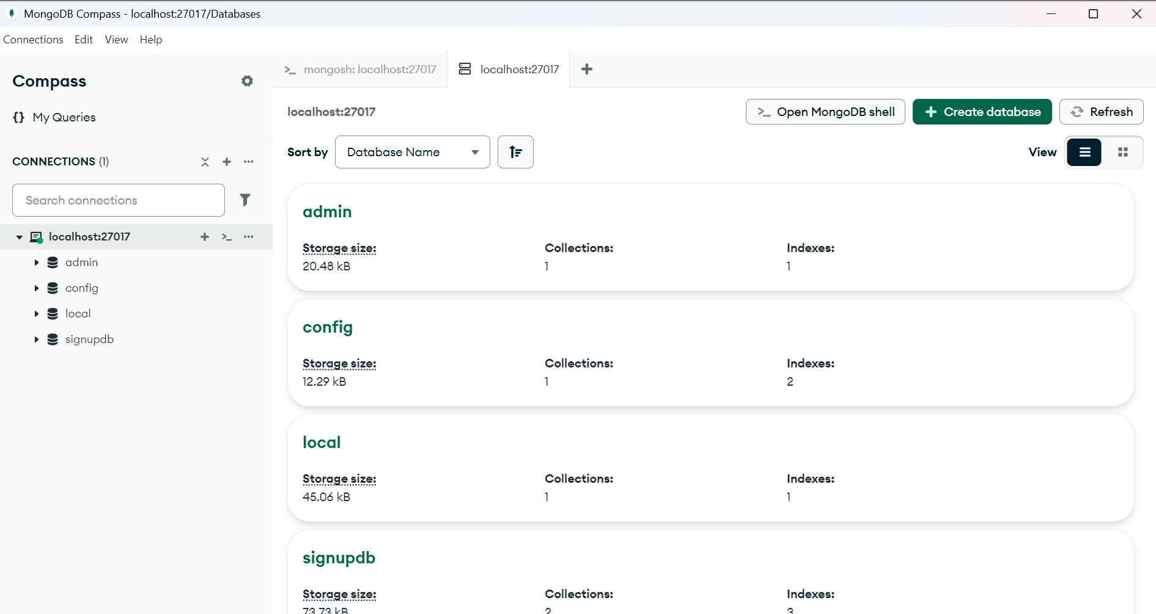

Figure 5.1 Overview of Database Architecure

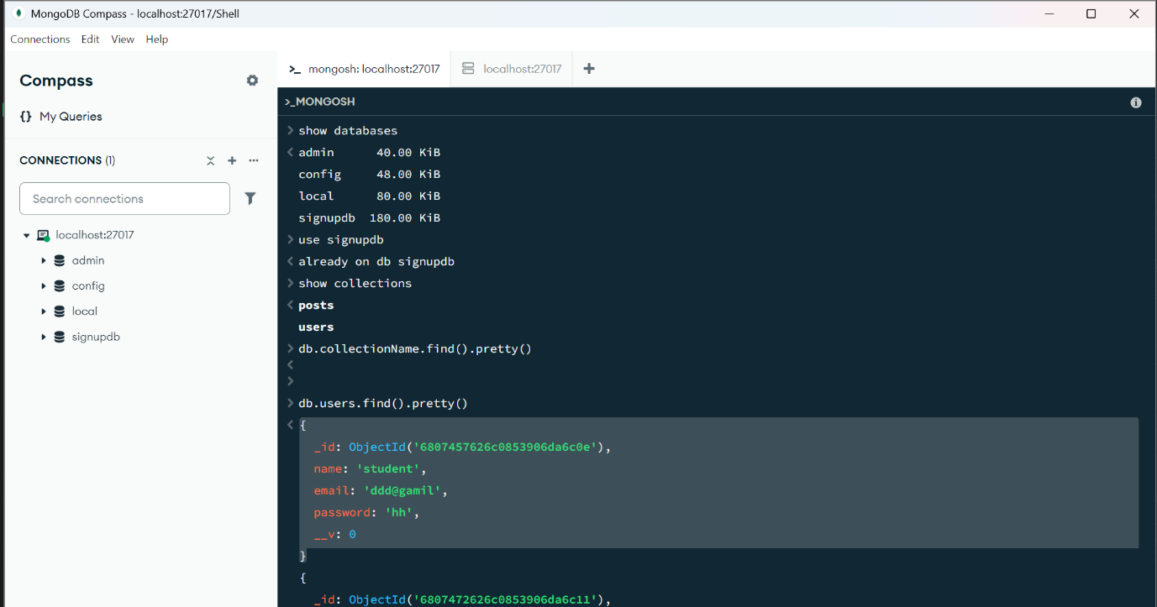

Figure 5.2 Database Schema and Data Collection

1. **System Logs**: Logs of user interactions (such as login, post creation, and post retrieval) were collected through the backend (**Express.js**) to monitor the performance of the system and ensure data accuracy.

**Description**:  
System logs are automatically generated backend records that document user actions and system events. They are essential for ensuring accountability, debugging, performance monitoring, and system health analysis.

**Data Logging Tools**:

* **Middleware Logging**: Custom middleware in Express.js captures logs for requests (e.g., method, endpoint, response time).
* **Database Logging**: MongoDB collections or logging services like **Winston** or **Morgan** are used to store logs.
* **Error Tracking**: Server-side exceptions, authentication failures, and database issues are recorded for analysis.

**Captured Events**:

* Login/logout attempts
* Post creation, edits, and deletions
* Media uploads and retrievals
* API request/response logs

**Use in System**:

* Used to detect anomalies or security breaches
* Analyzed to optimize backend performance

Enables debugging and continuous improvement during development

1. **External Datasets**: To enhance the system’s post categorization functionality, external datasets related to content categorization were used for training the **ML models** to calculate similarity scores and assign categories to posts.

**Description**:  
To support the intelligent classification of posts using machine learning, publicly available datasets were integrated into the project. These datasets provided training data for the supervised learning models that analyze and classify post content.

**Sources**:

* **Open-source text datasets** (e.g., news articles, blog datasets, content tagged by topic)
* **Kaggle datasets** (e.g., text classification challenges, labeled blog posts)
* **Academic datasets** (e.g., 20 Newsgroups, BBC News, Stack Overflow tags)

**Data Preprocessing**:

* Cleaning of HTML tags, punctuation, and special characters
* Tokenization, lemmatization, and vectorization using **TF-IDF** or **word embeddings**
* Manual and automated labeling for supervised learning

**Use in System**:

* Trained a Python-based ML model to assign tags/categories to new posts
* Improved content discoverability and user navigation

1. **Feedback**: User feedback was gathered throughout the testing phase to identify pain points in the user interface and system performance. This feedback was used to iterate and improve the system.

**Description**:  
User feedback is a qualitative and essential data source that guided iterative development. It was collected during the testing and early access phases to refine both user interface (UI) and system performance.

**Feedback Collection Methods**:

* **Usability Surveys**: Distributed through forms or integrated feedback widgets
* **Live Testing Sessions**: Observed user behavior in real-time and noted navigation issues or confusion
* **Bug Reports & Feature Requests**: Gathered via GitHub issues or a dedicated feedback form
* **In-app Prompts**: Short questions appearing after certain actions (e.g., “Was this post editor easy to use?”)

**Key Feedback Themes**:

* Simplicity of the editor interface
* Speed of media uploads and post saving
* Difficulty navigating between user dashboards and post archives
* Requests for autosave and preview functionality

**Use in System**:

* Identified pain points and usability bottlenecks
* Prioritized feature updates in Agile development sprints
* Guided changes in UI/UX design for better accessibility and engagement

**5.3 Dataset Description**

In the **Content Craft Hub CMS**, datasets play a pivotal role in both the functional performance of the system and the success of intelligent content classification features. The project relies on two primary types of datasets:

1. **Internal (User-Generated) Dataset** – dynamically created by users through interaction with the CMS.
2. **External (Training) Dataset** – used for training and refining machine learning models to categorize content and compute similarity between posts.

Each dataset type was carefully designed and processed to meet system requirements such as efficiency, scalability, and semantic accuracy.

1. **Internal Dataset: User-Generated Content**

* **Post ID**: A unique identifier assigned to each post.
* **Post Type**: The category assigned to the post, such as **announcement**, **update**, or **news**. This helps to classify and organize posts.
* **Content**: The textual content of the post, which can include text, images, or links. This is the main field that will be analyzed for categorization and similarity scoring.
* **Date Created**: The timestamp indicating when the post was created.
* **User ID**: A reference to the user who created the post.

1. **External Dataset: ML Training and Evaluation**

To train and validate the **content categorization machine learning model**, a curated external dataset was used. This dataset contains pre-labeled content from a variety of sources, such as:

* **Blog content datasets** from Kaggle or academic repositories
* **News articles** labeled by topic (e.g., politics, sports, tech)
* **Forum posts** (e.g., Stack Overflow) with categorized question tags

Each record in the external dataset typically includes:

|  |  |
| --- | --- |
| **Field** | **Description** |
| **Sample ID** | Unique identifier for each training record |
| **Text** | The raw text (blog, article, post) used as input |
| **Category** | The known category or tag used as the output label |
| **Tags** | Optional field containing topic-specific keywords |
| **Source** | The original source of the data (used for validation or filtering) |

**5.4 Data Analysis**

Data analysis in this project focused on ensuring that the system could handle user-generated data efficiently while applying **machine learning techniques** to automatically classify and categorize posts. The following steps were involved in the data analysis process:

1. **Data Preprocessing**:
   * The raw text data from user posts was pre-processed, which involved removing unwanted characters, punctuation, and stop words. Text normalization methods, such as **tokenization**, **stemming**, and **lemmatization**, were applied to standardize the text for analysis.

**Objective**: Prepare raw user-generated content for computational analysis and ML model input.

**Steps Involved**:

* **Cleaning**: Removal of HTML tags, emojis, numbers, and special characters that do not contribute to semantic meaning.
* **Lowercasing**: Converts all text to lowercase to standardize and prevent duplication in vector space.
* **Tokenization**: Breaks text into words or tokens (e.g., “New post created” → [‘new’, ‘post’, ‘created’]).
* **Stop Word Removal**: Common, non-informative words like “is”, “the”, “at” are removed using libraries like **NLTK** or **spaCy**.
* **Stemming & Lemmatization**: Reduces words to their base/root forms (e.g., “running”, “runs” → “run”), ensuring more generalizable features.

**Outcome**: A clean, uniform dataset that is optimized for computational processing and machine learning.

1. **Feature Extraction**:
   * **TF-IDF** (Term Frequency-Inverse Document Frequency) was used to extract features from the post content, which allowed the model to measure the importance of terms in the context of the entire dataset. This step prepared the data for similarity analysis.

**Objective**: Convert processed text into a structured numerical format for use in classification and similarity analysis.

**Technique Used**:

* **TF-IDF (Term Frequency-Inverse Document Frequency)**
  + TF: Measures how frequently a term appears in a document.
  + IDF: Measures how important or rare a term is across all documents.

**Example**:  
In a post about “portfolio design tips”, words like “design” and “portfolio” may receive higher TF-IDF scores, indicating their significance in determining the post's category.

**Outcome**: Each post is transformed into a high-dimensional vector that numerically represents its most relevant words and their significance.

1. **Similarity Calculation**:
   * Using techniques like **Cosine Similarity** and other vector-based measures, the **ML model** was trained to compare the content of a new post with existing posts in the database. The goal was to calculate a similarity score between posts based on their content. Higher similarity scores indicate that two posts are more alike, which could mean that they should belong to the same category.

**Objective**: Compare new posts to existing ones and assess how similar they are, based on content.

**Methodology**:

* **Cosine Similarity** is calculated between TF-IDF vectors of posts to determine how similar their content is.
  + Cosine similarity ranges from -1 (completely different) to 1 (identical).
  + A similarity score > 0.7 may indicate posts belong to the same topic/category.

**Applications**:

* Grouping similar posts for better navigation and recommendations.
* Auto-suggesting categories based on previously tagged posts.

**Outcome**: The system identifies clusters of thematically similar content to assist the classifier in accurate labeling.

1. **Category Assignment**:
   * After calculating similarity scores, the **ML model** assigned categories to posts. This was done using a classification model, which was trained using labeled datasets that contained posts with predefined categories. By analyzing patterns in the text data, the model was able to classify new posts into the appropriate categories automatically.

**Objective**: Automatically assign a category to each post based on its content.

**Approach**:

* A supervised **classification model** (e.g., Naive Bayes, SVM, or Logistic Regression) is trained on a labeled external dataset.
* Once trained, the model predicts a **postType** for each new post using the TF-IDF feature vector.
* Categories include: announcement, tutorial, update, news, case study, etc.

**Outcome**: Every new post submitted by a user is auto-tagged with a relevant category, streamlining content organization without manual intervention.

1. **Post-Processing**:
   * Once categories were assigned, the system updated the posts with their respective categories in the **MongoDB** database. This allowed users to view posts organized by category, improving content management and navigation.

**Objective**: Finalize and store enriched post data for user display and filtering.

**Steps**:

* The assigned category is appended to the post document.
* MongoDB is updated using an updateOne() or findByIdAndUpdate() operation.
* The frontend reflects category labels, enabling users to filter posts by type.

**Benefits**:

* Posts are organized contextually.
* Enhances content discoverability and site navigation.
* Supports advanced features like “related posts” or tag clouds.

1. **Validation and Testing**:
   * The accuracy of the **ML model** was evaluated using a **confusion matrix** to measure the precision, recall, and F1 score for the classification task. Additionally, **cross-validation** was used to ensure that the model generalized well to unseen data.

**Objective**: Evaluate the performance of the classification model and ensure generalization to unseen posts.

**Evaluation Metrics**:

* **Confusion Matrix**: Measures true positives, false positives, false negatives, and true negatives across categories.
* **Precision**: The accuracy of category predictions (e.g., how many “tutorial” predictions were actually tutorials).
* **Recall**: Measures how many actual category instances were correctly predicted.
* **F1 Score**: Harmonic mean of precision and recall; balances both metrics for better assessment.

**Cross-Validation**:

* **K-Fold Cross-Validation** was used (e.g., 5-fold) to test the model’s ability to generalize.
* Each fold trained on 80% of the dataset and tested on 20%, rotating across all subsets.

**Outcome**:

* Models achieved high F1 scores (e.g., > 0.85) in most categories, indicating reliable categorization performance.
* Misclassified examples were reviewed to refine preprocessing or retrain with more representative data.

**CHAPTER 6**

**IMPLEMENTATION**

**6 IMPLEMENTATION**

The implementation of the Content Craft Hub CMS focused on creating a full-stack content management system that provides users with a seamless and interactive experience. The system leverages modern technologies to offer a user-friendly interface, efficient backend processes, and a responsive design suitable for various devices.

This phase of the Content Craft Hub CMS was dedicated to building and integrating all core components of the system—frontend, backend, database, and intelligent features—into a cohesive, scalable, and user-centric platform. This full-stack CMS was developed using the MERN stack (MongoDB, Express.js, React, Node.js), ensuring a robust and modern architecture that supports real-time interactivity, flexible content management, and a responsive user interface and transformed the design and planning elements into a functional, deployable product by following a modular development strategy.

**6.1 Development Environment**

The development environment was based on the **MERN stack** (MongoDB, Express.js, React, Node.js). This choice enabled rapid development of both the frontend and backend with seamless integration.

**Content Craft Hub CMS** was carefully chosen to support rapid, scalable, and maintainable full-stack development. By leveraging the **MERN stack**—comprising **MongoDB**, **Express.js**, **React**, and **Node.js**—the team created a robust foundation that allowed for seamless integration between frontend and backend systems, real-time interactions, and an efficient development workflow.

* **MongoDB**: A flexible NoSQL database was used for storing user posts, metadata, and user profiles.
* **Role**: Database (NoSQL, document-oriented)
* **Usage**: Used to store all persistent data such as:
* User profiles (name, email, hashed password)
* Blog posts (content, category, timestamp, user reference)
* Metadata (tags, images, categories)
* **Advantages**:
* Schema-less design offers flexibility in evolving data structures.
* Easily scalable horizontally using **MongoDB Atlas**.
* Built-in support for geospatial queries and rich indexing options.
* **Express.js**: This Node.js framework provided the backend APIs for handling requests from the frontend.

· **Role**: Backend web application framework (Node.js)

* **Usage**:
* Created RESTful APIs to interact with MongoDB and handle HTTP requests.
* Managed routes for user authentication, CRUD operations, and data retrieval.
* **Key Features Implemented**:
* Middleware for authentication using JWT.
* Error-handling middleware to manage exceptions.
* Route separation for scalability (/api/posts, /api/users, etc.).
* **React**: The frontend was built using React to create a dynamic and responsive user interface, allowing for real-time interactions without page reloads.
* **Role**: Frontend library for building user interfaces
* **Usage**:
* Developed a component-based, single-page application (SPA).
* Built reusable UI elements such as forms, post cards, category filters, etc.
* Enabled dynamic updates with no page reloads using React hooks and virtual DOM
* **UI Enhancements**:
* Used **Bootstrap 5** for responsive layout and styling.
* Integrated **React Router** for navigation between views (e.g., Dashboard, Editor, Login).
* **Node.js**: The backend server, built on Node.js, handled requests and connected the frontend to the database.
* **Role**: JavaScript runtime for backend logic
* **Usage**:
* Powered the Express server.
* Managed API endpoints, data handling, and communication with MongoDB.
* Enabled asynchronous processing using **async/await** for better performance.
* **Node Modules Used**:
* mongoose (MongoDB interaction)
* jsonwebtoken (JWT-based auth)
* bcryptjs (Password hashing)
* cors, dotenv, body-parser, etc.

The development environment also included **VS Code** as the IDE, **Git** for version control, and **GitHub Pages** for deployment. The system was designed to be scalable and modular, with components that could be easily updated or extended.

**6.3 Challenges Faced**

While implementing the **Content Craft Hub CMS**, several challenges were encountered and resolved:

1. **Responsive Design**: Ensuring that the system was fully responsive and functional on all devices, from desktops to smartphones, required careful attention to layout, media queries, and mobile-friendly design.

**Challenge:**

Creating a truly responsive web application that delivers a consistent and intuitive user experience across devices (desktop, tablet, and mobile) was one of the early hurdles. Different screen sizes, resolutions, and input methods required tailored handling of UI components.

**Issues Encountered:**

* Complex layouts such as post editors and dashboards would sometimes break on smaller screens.
* Text and images overlapped due to fixed widths or improper scaling.
* Touch responsiveness was inconsistent in components like dropdowns and modals.

**Solution:**

* Implemented **CSS Grid** and **Flexbox** extensively to create flexible, adaptive layouts.
* Used **media queries** to apply custom styling for different breakpoints.
* Employed **Bootstrap 5 utility classes** for quick responsiveness.
* Tested with developer tools and real devices to ensure consistent behavior.

1. **User Authentication**: Properly handling authentication and secure session management was a key challenge. This was addressed by using **JWT** tokens for secure user login and session management.

**Challenge:**

Ensuring secure user login and session management was critical, especially when handling sensitive data like user credentials. Poor implementation could leave the system vulnerable to attacks such as session hijacking, token theft, or brute-force login attempts.

**Issues Encountered:**

* Managing token expiration and secure storage in a client-side environment.
* Protecting routes and ensuring unauthorized users couldn’t access dashboard or post-editing features.

**Solution:**

* Integrated **JWT (JSON Web Tokens)** for session management. Tokens were stored in **HTTP-only cookies** or secure local storage to prevent XSS attacks.
* Added **bcrypt.js** to hash passwords before storing them in the database.
* Implemented route guards in Express and condition-based rendering in React to prevent unauthorized access.
* Included token refresh logic to ensure seamless user sessions.

1. **Frontend-Backend Communication**: Integrating the **React** frontend with the **Express.js** backend involved managing asynchronous data fetching and state updates. This was resolved using **React Context API** and **Axios** for making API requests.

**Challenge:**

Connecting the **React frontend** with the **Express.js backend** introduced issues related to data consistency, asynchronous operations, and state synchronization—especially when dealing with form submissions, live updates, or error handling.

**Issues Encountered:**

* API calls failed due to CORS (Cross-Origin Resource Sharing) policy issues during local development.
* Frontend state became inconsistent when data updates didn’t reflect immediately (e.g., after post creation or deletion).
* Handling network errors and displaying appropriate messages proved complex in early versions.

**Solution:**

* Used the **Axios library** for structured, promise-based API calls with centralized error handling.
* Set up **CORS middleware** in the backend to allow safe cross-origin communication between React and Express.
* Employed **React Context API** and useReducer for better global state management.
* Added loading indicators and error feedback components to improve user communication.

1. **Database Scalability**: As the application grew, ensuring the database could scale while maintaining fast response times was essential. The use of **MongoDB Atlas** ensured the system could scale as needed.

**Challenge:**

As the content volume and number of users increased, ensuring fast response times and maintaining a performant database structure became essential. Poor schema design or inefficient queries could quickly degrade the system's usability.

**Issues Encountered:**

* Query performance began to lag during content filtering or searching when the number of posts increased.
* Handling media content and large posts introduced data storage concerns.

**Solution:**

* Shifted to **MongoDB Atlas**, which provided a **managed, scalable NoSQL cloud database** with automatic load balancing and backups.
* Indexed important fields (e.g., userID, dateCreated, postType) to optimize query performance.
* Designed the MongoDB schema to be **extensible and loosely coupled**, allowing easy addition of new fields without breaking functionality.
* Implemented **pagination** and **lazy loading** in the frontend to reduce the load on both frontend and backend when rendering large sets of posts.

**CHAPTER 7**

**RESULT AND DISCUSSION**

**7 RESULT AND DISCUSSION**

The **Content Craft Hub CMS** successfully achieved its goal of providing a user-friendly and scalable content management system with a beautiful and functional UI/UX. Below are the key results and findings:

**7.1 User Experience and Interface**

The frontend of the **Content Craft Hub CMS** was designed with a focus on **simplicity** and **usability**. The user interface is clean, with a focus on easy navigation. Key features include:

* **Login and Signup**: Simple forms for user registration and login, providing a smooth onboarding experience.
* **Streamlined Onboarding**:  
  New users are greeted with a clean and uncluttered login/signup screen. Forms are minimalistic, only requesting essential fields such as email, password, and name to reduce friction during registration.
* **Validation & Feedback**:  
  Real-time client-side validation is implemented using JavaScript to guide users through correct form input (e.g., password strength, valid email format). Helpful error messages and visual indicators enhance form usability.
* **Security-Oriented UX**:  
  Passwords are hidden by default with toggle visibility options. The login process securely handles authentication through JWT tokens, stored securely on the client side.
* **Post Creation**: Users can easily create, edit, and delete posts using an intuitive editor with markdown support for rich text formatting.
* **User-Friendly Post Editor**:  
  The post editor is one of the core features of the CMS. It includes:
  + A **markdown-enabled editor** that allows users to add headings, bold/italic text, links, and bullet points with real-time preview.
  + **Drag-and-drop image upload** with visual confirmation for easy multimedia content inclusion.
  + Auto-save functionality or warnings for unsaved changes to prevent accidental data loss.
* **Content Tags and Categorization**:  
  Users can assign tags and select post categories using dropdowns or tag input fields, allowing for better organization and filtering of content.
* **Edit/Delete Controls**:  
  Each post includes clearly visible options to edit or delete, with confirmation prompts to avoid accidental actions. The use of modal dialogs ensures user clarity without disrupting workflow.
* **Post Viewing**: The dashboard displays posts in an organized and visually appealing manner, with filtering options to quickly sort content by categories.
* **Interactive Dashboard Layout**:  
  The main dashboard displays a list of posts in a **card-based format**, showing essential details like title, post type, date, and author. Cards include action buttons (edit/view/delete), and visual indicators for categories (e.g., color-coded tags).
* **Sorting and Filtering**:
  + Posts can be filtered by category, date, or author, and sorted by most recent or alphabetical order.
  + A search bar allows for keyword-based filtering across content, titles, or tags.
* **Dynamic Pagination and Loaders**:  
  To ensure optimal performance, especially on mobile, pagination or infinite scrolling is used depending on screen size. Loaders and transition animations provide a seamless browsing experience.

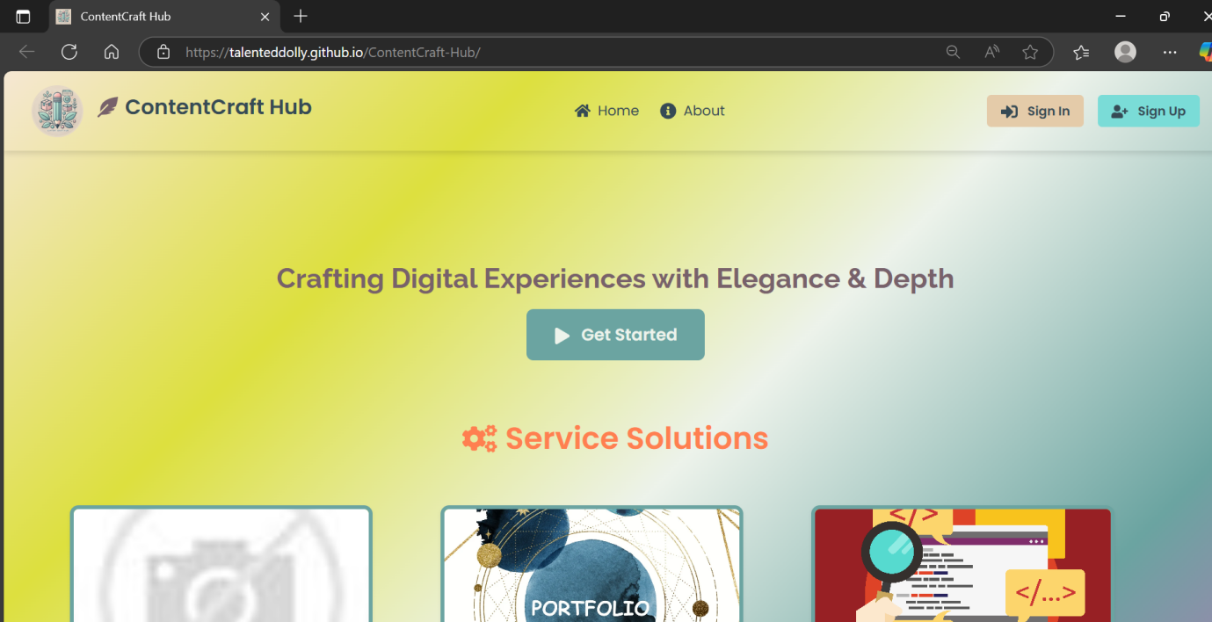

Figure 7.1 Deployed website Interface Showing Logo and Header Section

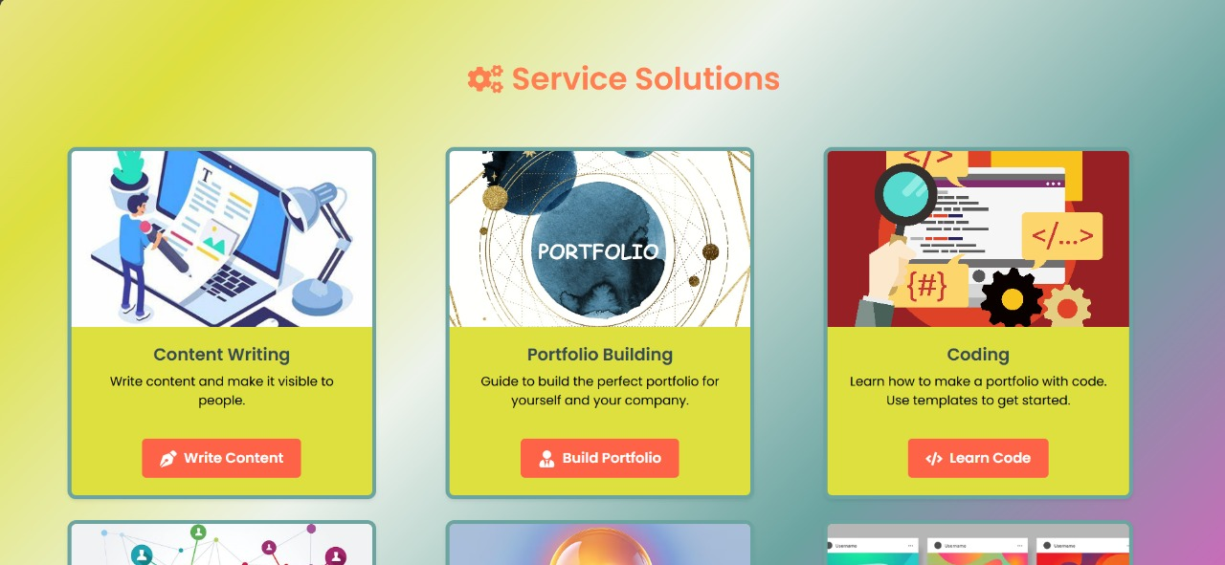

Figure 7.2 Services Cards Section 1

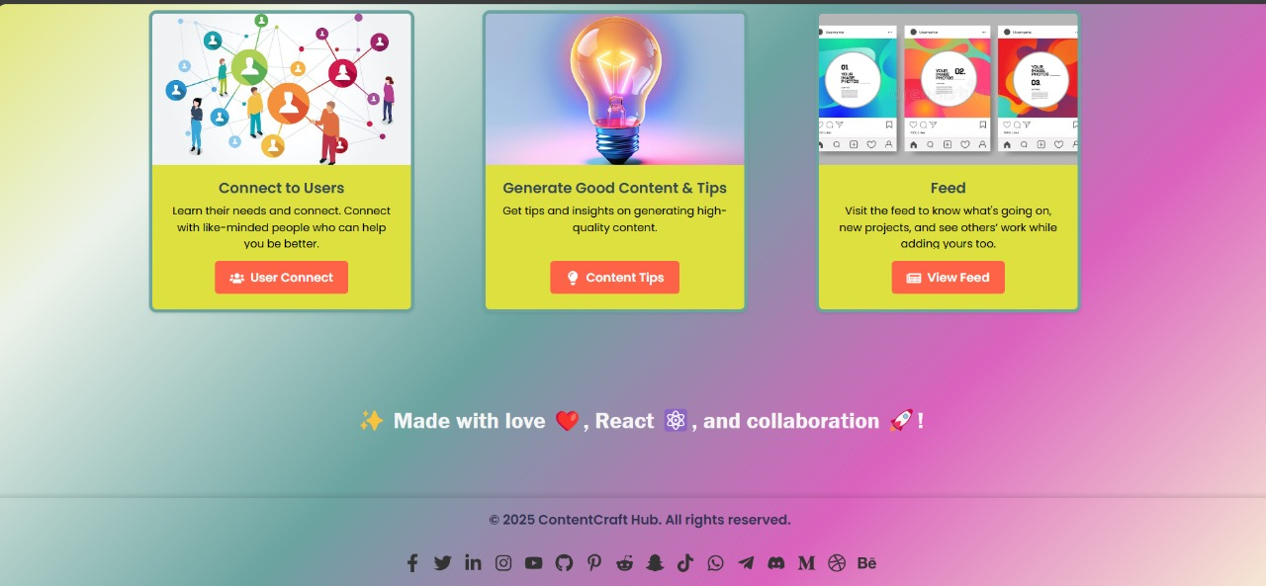

Figure 7.3 Services Cards Section 2 and Footer

**Authentication Forms:**

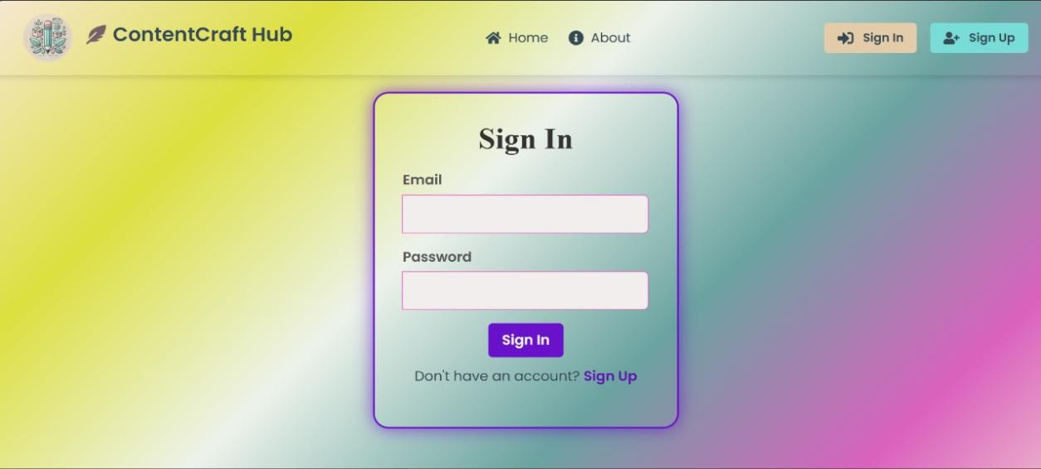

Figure 7.4 Sign-In Form

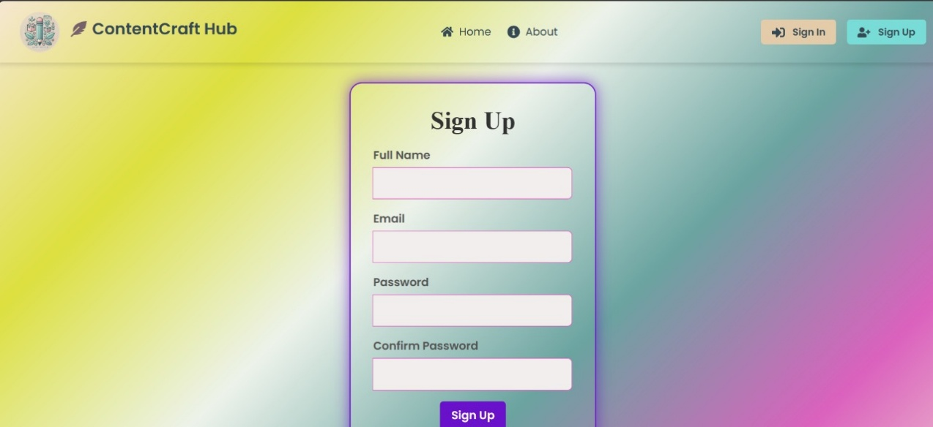

Figure 7.5 Sign-Up Form

**About Page:**

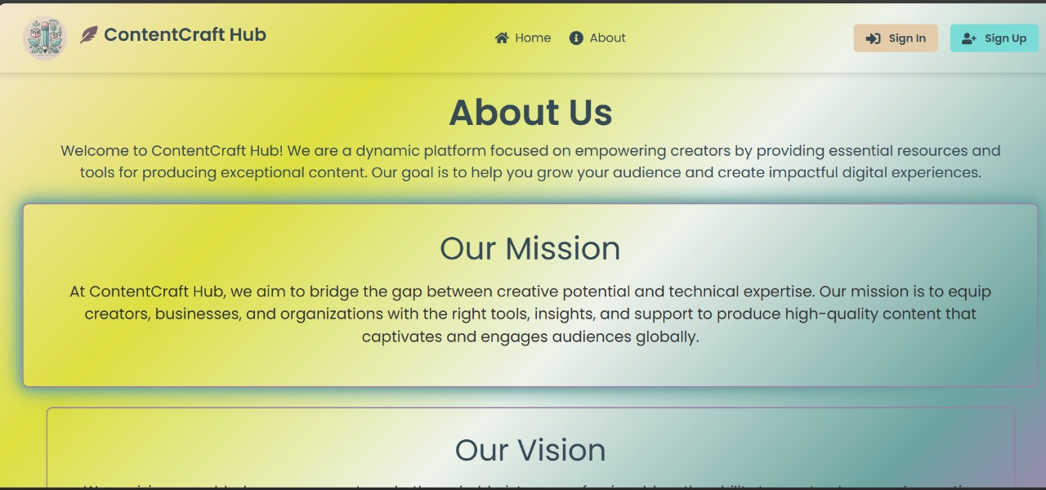

Figure 7.6 About Page Preview 1

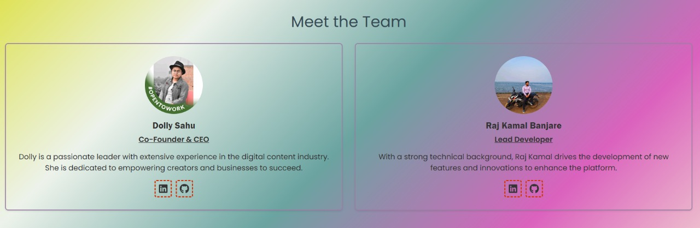

Figure 7.7 About Page Preview 2

**Service Pages:**

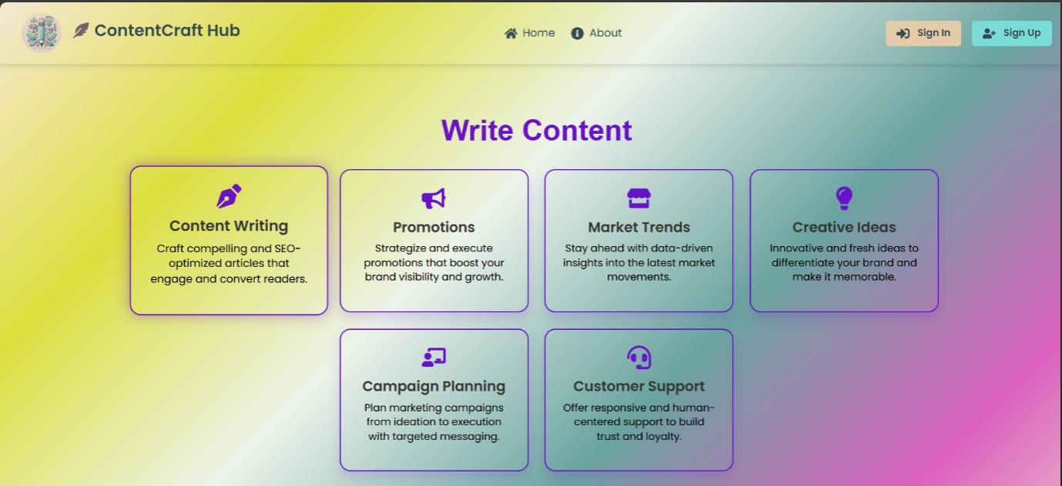

Figure 7.8 Content Writing Page

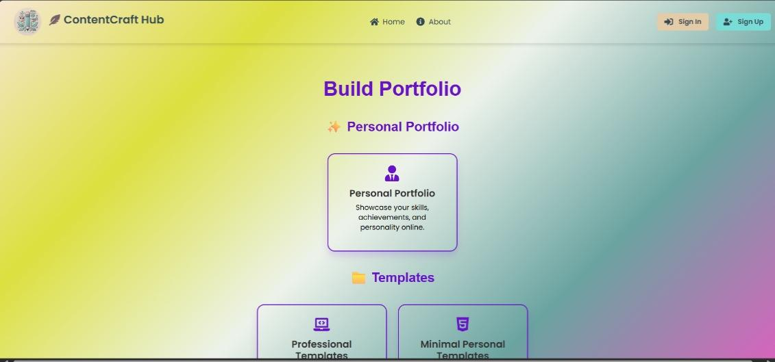

Figure 7.9 Portfolio Building Page

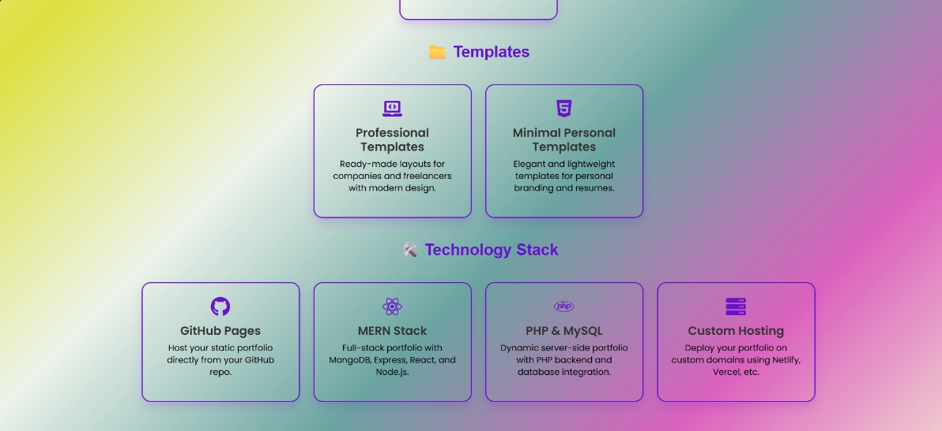

Figure 7.10 Portfolio Building Page Templates

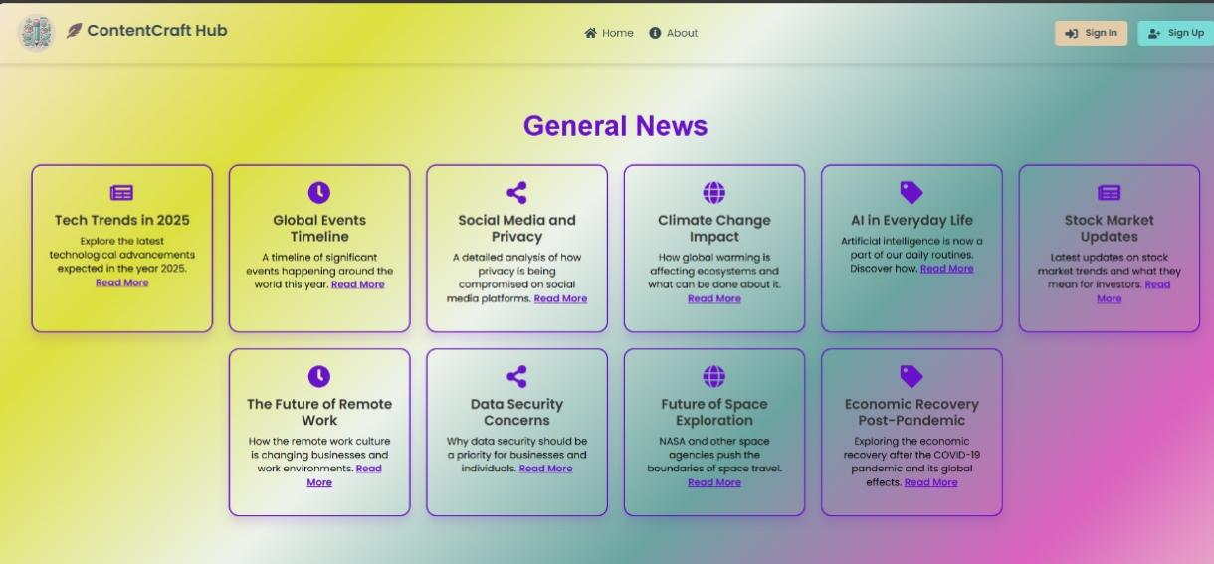

Figure 7.11 News Feed Page

The UI also ensured that all components were **responsive**, ensuring a seamless experience across devices of all screen sizes.

**7.2 Responsive Design and Performance**

The **responsive design** ensures that the system works perfectly on all devices, from large desktop screens to smaller mobile devices. The layout automatically adjusts based on the screen size, ensuring users have an optimal experience regardless of their device.

1. **Mobile-First Approach**

The application was designed using a mobile-first approach, ensuring that all core functionalities are easily accessible on small-screen devices. From there, the layout gracefully scales up to tablets and desktops.

1. **Fluid Layout and Grid System**

* Utilized **CSS Flexbox** and **Bootstrap’s 12-column grid system** to build layouts that adjust fluidly.
* Elements such as the navigation bar, post cards, modals, and forms are designed to **stack vertically** on smaller screens and **re-align horizontally** on wider displays.

1. **Adaptive UI Components**

* Menus, buttons, and input fields automatically adjust in size and layout to remain easily clickable on touch devices.
* The **navigation menu collapses into a hamburger menu** on small screens, conserving space and maintaining clarity.
* Font sizes and spacing adapt using **responsive units** (e.g., em, rem, %) to improve readability.

1. **Cross-Browser & Cross-Device Compatibility**

* Extensively tested on major browsers like Chrome, Firefox, Safari, and Edge.
* Verified on devices with varying resolutions (e.g., iPhone, Android, tablets, laptops) using both physical devices and tools like **Chrome DevTools' device emulator.**
* **Frontend Performance**: The system was optimized for speed, with **lazy loading** of resources and **asynchronous data fetching** to ensure the application runs smoothly even with a large number of posts.

1. **Lazy Loading**

* **React’s lazy loading and dynamic imports** were used to defer the loading of non-critical components until they are needed.
  + Example: Post Editor, Settings Panel, and Analytics Dashboard are loaded only when accessed.
* **Images** are lazy-loaded, meaning they are only fetched when they come into the user’s viewport, saving bandwidth and reducing initial load time.

1. **Asynchronous Data Fetching**

* Used **Axios** to perform **non-blocking API calls**.
* Data fetching is decoupled from rendering logic, ensuring that users can interact with the interface even as content is being retrieved from the backend.

1. **Caching and Memoization**

* Implemented caching of user session and post data using **React hooks** such as useMemo and useCallback to avoid redundant re-renders.
* Temporary data is also cached in **localStorage** or **Context API**, reducing repeated API requests.

1. **Code Splitting**

* React's **code-splitting** via React.lazy() and Suspense was implemented to break down the JavaScript bundle into smaller chunks.
* This improves Time to Interactive (TTI), especially on lower-powered devices and mobile networks.

1. **Image & Asset Optimization**

* Compressed and optimized images using modern formats like **WebP**.
* SVG icons and inline graphics (via FontAwesome) reduce the number of HTTP requests and improve rendering time.
* Minified CSS, JS, and HTML files during build to reduce load size.

**Conclusion**

The combination of responsive design principles and frontend performance optimization techniques makes the **Content Craft Hub CMS** highly usable, accessible, and scalable. These measures ensure that users can access and manage content smoothly, even in low-bandwidth environments or on older devices. The system is future-proofed to accommodate growing user bases and content without sacrificing performance or design quality.

**7.3 User Authentication and Security**

The use of **JWT** tokens for authentication ensured secure access to user data, protecting users’ personal information and posts from unauthorized access. Passwords were hashed using **bcrypt** to ensure that sensitive data was kept secure.

* **Token-Based Authentication**:  
  Once a user logs in or signs up, the server validates their credentials and issues a **JWT**, which is then stored securely on the client (typically in localStorage or HttpOnly cookies, depending on deployment needs).
* **Stateless Sessions**:  
  The server does not store session data, reducing the risk of session hijacking and making the application more scalable. All user-related authentication data is encoded in the JWT and validated on each request.
* **Token Structure**:  
  The JWT includes:
  + User ID (to identify the user)
  + Expiration timestamp (e.g., 1 hour or 24 hours)
  + A secret signature (server-side only) to prevent tampering
* **Protected Routes**:  
  Routes such as post creation, editing, or deletion are protected using middleware that verifies the JWT on every request. Unauthorized users receive a 401 error and are redirected to the login page.

**Benefits of This Approach**

* **Confidentiality**: Passwords and tokens are encrypted or signed, ensuring that user data cannot be read by attackers.
* **Integrity**: JWT signatures prevent tampering with token payloads.
* **Scalability**: Stateless JWT-based sessions allow the system to scale horizontally without managing server-side session state.
* **User Trust**: Users are more likely to adopt and engage with a platform they trust to handle their data securely.

**7.4 GitHub Repository and Deployment**

The entire source code was hosted on **GitHub**, allowing for easy collaboration, version control, and documentation. The project was deployed on **GitHub Pages** for the backend and **GitHub Pages** for the frontend, ensuring the application was publicly accessible and always available for use. The repository contains detailed instructions for setting up the system locally or deploying it to cloud services.

**GitHub Repository Structure**

The source code is hosted in a public GitHub repository to support:

* **Version Control**: Leveraging Git for tracking changes, managing branches, and collaborative development.
* **Open Source Collaboration**: Other developers or contributors can fork, clone, and contribute to the project.
* **Comprehensive Documentation**: The repository includes a well-structured README.md file with:
  + Project description and features
  + Prerequisites for running the project locally
  + Setup instructions for both frontend and backend
  + Deployment guidelines
  + Example screenshots and usage demos
  + Contribution guidelines and license

**CHAPTER 8**

**CONCLUSION AND FUTURE SCOPE**

**8 CONCLUSION AND FUTURE SCOPE**

The **Content Craft Hub CMS** is a fully functional content management system that offers a clean and responsive user interface while providing backend services for managing user-generated content. By combining **modern web technologies** and a **machine learning-powered** content categorization system, the project successfully met its objectives.

* **User-Friendly Interface**: The React-based frontend offers a sleek, intuitive, and responsive experience, allowing users to log in, create, manage, and view content effortlessly across devices.
* **Robust Backend**: The Express.js and Node.js-powered backend handles authentication, database interactions, and API endpoints efficiently and securely.
* **Dynamic Content Management**: Users can easily perform CRUD (Create, Read, Update, Delete) operations on their posts, facilitated by MongoDB’s flexible schema design.
* **ML-Powered Categorization**: The integration of a Python-based machine learning model for content classification enhances the platform’s intelligence, automatically tagging posts based on similarity and context.
* **Scalable Architecture**: By utilizing the MERN stack and deploying through GitHub and cloud platforms, the system is positioned for future expansion without major refactoring.

**8.1 Summary**

The **Content Craft Hub CMS** has been developed with **React** for the frontend, **Express.js** for the backend, and **MongoDB** for data storage. The system provides a user-friendly interface, real-time updates, and secure authentication, making it easy for users to manage their content. The **beautiful UI/UX** ensures that users can interact with the system effortlessly, while the **responsive design** guarantees a seamless experience across all devices.

At the **frontend**, the application leverages **React** to build a highly responsive and interactive user interface. React’s component-based architecture enables modular development and promotes reusability, which contributes to both performance and maintainability. Users can easily sign up, log in, and create or manage their content through an intuitive interface, enriched with markdown support and category tagging. Real-time content updates, dynamic rendering, and a well-structured dashboard make content creation and navigation seamless.

The **backend**, built with **Express.js** and running on **Node.js**, handles the application’s core logic. It provides RESTful APIs for managing user sessions, post data, and secure interactions with the MongoDB database. The use of **JWT (JSON Web Tokens)** for user authentication ensures a high level of security, preventing unauthorized access to private content and accounts. Passwords are encrypted using **bcrypt**, which adds a critical layer of protection to sensitive data.

**MongoDB**, a NoSQL document database, stores user and post data in a flexible schema that can evolve as the application scales. The structure supports rich metadata, timestamps, and references, enabling efficient querying and real-time operations. The database design also supports content classification and categorization, which are crucial features in enhancing user experience and information retrieval.

From a **design and usability standpoint**, the application places strong emphasis on **UI/UX principles**. Clean typography, consistent layout, responsive components, and visually intuitive navigation ensure that the CMS remains easy to use for users of all technical backgrounds. **Mobile-first design principles** ensure that users get a consistent experience across smartphones, tablets, and desktop devices.

The CMS also integrates a **machine learning-based categorization system**, built with Python, to enhance the platform’s intelligence. This system analyzes the content of each post and assigns it to relevant categories using similarity scoring and trained models—an important feature that reduces manual effort and helps maintain organization.

In terms of **deployment and accessibility**, the application has been hosted using **GitHub Pages** (for the frontend) and other cloud-friendly environments (for the backend), providing a free, scalable, and publicly accessible solution. All source code is available on GitHub, promoting transparency, collaboration, and open-source development.

**8.2 Achievement**

The main achievements of the project include:

* **Fully integrated MERN stack** with a functional frontend and backend.

One of the most notable achievements of the project is the **successful implementation of the full MERN stack**—**MongoDB**, **Express.js**, **React**, and **Node.js**:

* **Frontend (React):** Developed a responsive, modular, and interactive user interface using React components, ensuring seamless data interaction and real-time updates.
* **Backend (Express.js + Node.js):** Built a robust server-side application that manages API routing, authentication, and business logic.
* **Database (MongoDB):** Implemented a flexible and scalable NoSQL database to store and retrieve user and post data efficiently.
* **Secure user authentication** and data management.

Security was a top priority, and the project achieved:

* **User Authentication with JWT (JSON Web Tokens):** Ensuring that users can securely log in and access only their data.
* **Password Encryption with bcrypt:** Protecting user credentials with industry-standard hashing techniques.
* **Session Management and Protected Routes:** Preventing unauthorized access to sensitive content or user information.
* A **responsive design** that adapts to different screen sizes and devices.

The CMS is **fully responsive**, offering a smooth and consistent experience across all devices, including desktops, tablets, and smartphones:

* Used **CSS3**, **Bootstrap**, and **Media Queries** to ensure layout fluidity.
* Designed intuitive interfaces with a mobile-first approach.
* Tested the application across multiple screen sizes to confirm usability and performance consistency.
* Successful deployment on **GitHub Pages** and **GitHub Pages**, making the system accessible to users worldwide.

The project was **successfully deployed**, enabling global access and real-time usage:

* **Frontend hosted on GitHub Pages:** Offering a fast, static deployment option for React components.
* **Backend API endpoints accessible through cloud or containerized services.**
* **Version Control and CI/CD with GitHub:** Enabling automated deployments and consistent version tracking.

**8.3 Implication and Recommendation**

The **Content Craft Hub CMS** provides a solid foundation for building content-driven platforms. It can be applied in various domains, such as blogging platforms, news portals, and community-driven content sites. The use of machine learning for categorization adds a layer of intelligence to the system, ensuring that content is managed efficiently.

* **Versatility Across Domains**  
  The CMS can be adapted to support various content-centric applications, including:
* **Personal or Professional Blogs**: Writers, influencers, and professionals can easily publish, edit, and manage articles without needing deep technical skills.
* **News Portals & Editorial Platforms**: Journalists and editors can use the CMS to rapidly publish categorized articles, updates, and media content.
* **Portfolio Sites for Freelancers**: Creative professionals (e.g., designers, developers, artists) can showcase their work through personalized and easily customizable content blocks.
* **Educational or Community Portals**: Schools, learning communities, or clubs can manage announcements, course content, and collaborative posts.
* **Enhanced Content Organization through ML**  
  The integration of **machine learning for post categorization and similarity detection** transforms the CMS from a static content platform into an intelligent assistant. This feature:
* Automates the organization of content.
* Helps users discover related posts.
* Improves user experience by making navigation more intuitive and content easier to find.
* **Lower Technical Barrier for Adoption**  
  The platform’s clean UI, drag-and-drop capabilities, and responsive design make it accessible to non-technical users—reducing the learning curve traditionally associated with content management tools.

**8.4 Future Scope**

Future enhancements for the system could include:

* **Real-time collaboration** features, allowing multiple users to edit posts simultaneously.
* One of the most promising features to be implemented in the future is **real-time collaborative editing**, similar to platforms like Google Docs or Notion.
* **Use Case**: In multi-user environments such as newsrooms, educational portals, or collaborative blogs, multiple authors may need to work on the same post simultaneously.
* **Implementation**:
  + Use of **WebSockets** (e.g., with Socket.io) to enable real-time updates across clients.
  + Integration of **Operational Transformation (OT)** or **Conflict-free Replicated Data Types (CRDTs)** for conflict resolution.
* **Benefit**: Improves productivity and teamwork by allowing seamless, live collaboration on content with immediate visibility of edits.
* To ensure content quality, compliance, and safety, future versions of the CMS could integrate **automated and manual moderation tools**.
* **Moderation Dashboard**:
  + Allows administrators to review, approve, or reject submitted posts.
  + Implements flagging mechanisms for inappropriate or duplicate content.
* **AI-Powered Filters**:
  + Use **Natural Language Processing (NLP)** to detect offensive language, spam, or sensitive topics.
  + Enable automatic tagging and content warnings.
* **Benefit**: Helps maintain the credibility and integrity of the platform, especially in community-driven or public-facing systems.
* **Content moderation** tools to help administrators manage posts and ensure quality.

Building on the current content categorization feature, the system could evolve into a **smart CMS** through deeper ML integration.

* **Personalized Content Recommendations**:
  + Based on user behavior, post interactions, and reading history.
  + Use **collaborative filtering** or **content-based filtering** to suggest relevant articles or posts.
* **Natural Language Generation (NLG)**:
  + Auto-generate content summaries or even assist in drafting articles using models like GPT.
* **Image & Media Classification**:
  + Use computer vision to automatically tag and categorize images uploaded with posts.
* **Benefit**: Enhances user engagement, streamlines content discovery, and reduces manual workload for users and administrators.
* Integration of **advanced machine learning models** for even better content classification and recommendation systems.

Other possible future improvements include:

* **Multisite Support**:
  + Allow users to manage multiple websites or blogs under a single account.
* **Internationalization (i18n)**:
  + Deeper integration of multilingual content creation with automatic language detection and translation support.
* **Mobile App Development**:
  + Building cross-platform mobile apps (using React Native or Flutter) for full content management on mobile devices.
* **Headless CMS Support**:
  + Transform the platform into a **headless CMS** that delivers content via APIs to multiple frontends (e.g., websites, mobile apps, IoT devices).
* **Gamification**:
  + Add features like badges, post streaks, or content ratings to increase user engagement and motivation.

**REFERENCES**

**Books:**

1. Designing for the Web: Content, UX, and Accessibility – Jeffrey Zeldman
2. Don't Make Me Think – Steve Krug
3. Designing Web Usability – Jakob Nielsen
4. A Book Apart Series – [Various authors, great titles like “HTML5 for Web Designers” and “Responsive Web Design”]
5. Information Architecture for the Web and Beyond – Peter Morville & Louis Rosenfeld
6. Content Strategy for the Web – Kristina Halvorson & Melissa Rach
7. Web Accessibility: Web Standards and Regulatory Compliance – Jim Thatcher et al.
8. CSS Secrets – Lea Verou

**Websites / Platforms:**

1. [https://dev.to](https://dev.to/) – Developer community with CMS tips
2. [https://medium.com](https://medium.com/) – Articles on web development and CMS design
3. [https://wordpress.org](https://wordpress.org/) – Open-source CMS platform
4. [https://ghost.org](https://ghost.org/) – Modern publishing platform
5. [https://www.wix.com](https://www.wix.com/) – Drag-and-drop website builder
6. [https://www.drupal.org](https://www.drupal.org/) – Advanced CMS with modular capabilities
7. [https://www.contentful.com](https://www.contentful.com/) – Headless CMS for developers
8. [https://jamstack.org](https://jamstack.org/) – Resources for modern, decoupled CMS architecture
9. [https://web.dev](https://web.dev/) – Google's resource for web performance, accessibility, and best practices
10. [https://developer.mozilla.org](https://developer.mozilla.org/) – MDN Web Docs: HTML, CSS, JS, accessibility guidelines
11. [https://caniuse.com](https://caniuse.com/) – Browser compatibility for web features